**Module 4 Activity 2: Setting up MongoDB in Cloud Environment**

Saurabh Kale

IFT 458/554: Middleware Programming & Database Security

Dinesh Sthapit

Sep 29th, 2023

**Table of Contents**

**Step 1 - Start by setting up additional environment variables in "config.env".** 4

**Step 2 - Create the associated files in the correct folder - loanRoutes.js, loanController.js and loanModel.js in the model folder.** 5

**Step 3 – Server.js file** 11

**Step 4 – Create a folder and name it as dataBaseManager** 12

**Step 5 – Controller file** 13

**Step 6 – App.js file** 14

**Step 7 – The App ran displaying the PORT number and LISTEN Message** 15

**Step 8 – Add a new loan (POSTMAN).** 16

**Step 9 – Add 5 additional loans (POSTMAN).** 17

**Step 10 – Get Users To get all users, enter http://localhost:<PORT-NUMBER>/loans/ as the address. Remember to select the verb as GET.** 22

**Step 11 – Get a Specific User (POSTMAN) Get the data of a specific user by entering this URL: http://localhost:<PORT_NUMBER>/loans/:id** 26

**Step 12 – Change an Existing Loan (POSTMAN) Change an existing LOan by using the PUT verb. Then change the value of the JSON object. The URL is the same as when we fetched the specific Loan.** 27

**Step 13 – This criterion is linked to a Learning OutcomeDelete a User (POSTMAN) To delete a loan, you only need to change the verb to DELETE. We can verify that the user is gone by fetching all the loans. Now Verify that you have a fully working express backend connected to a MongoDB database.** 29

**Step 14 – Create a collection in POSTMAN and all your TEST there and then EXPORT POSTMAN TEST COLLECTION to a json file.** 31

**Step 15 – Finally, Add code to display the Connection String you used in the CONSOLE** 34

**GitHub Repo Link** 35

**Step 1 – Start by setting up additional environment variables in “config.env”.**

*Screen shot showing the config.env file with all the environment variables.*

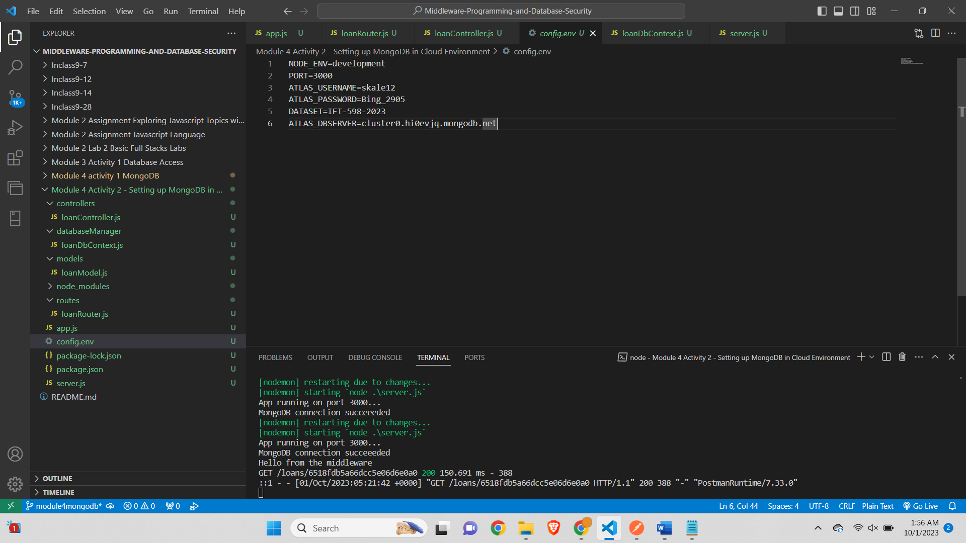

**Step 2 - Created the associated files in the correct folder - loanRoutes.js, loanController.js and loanModel.js in the model folder.**

Screenshot of the **loanRouter.js** file

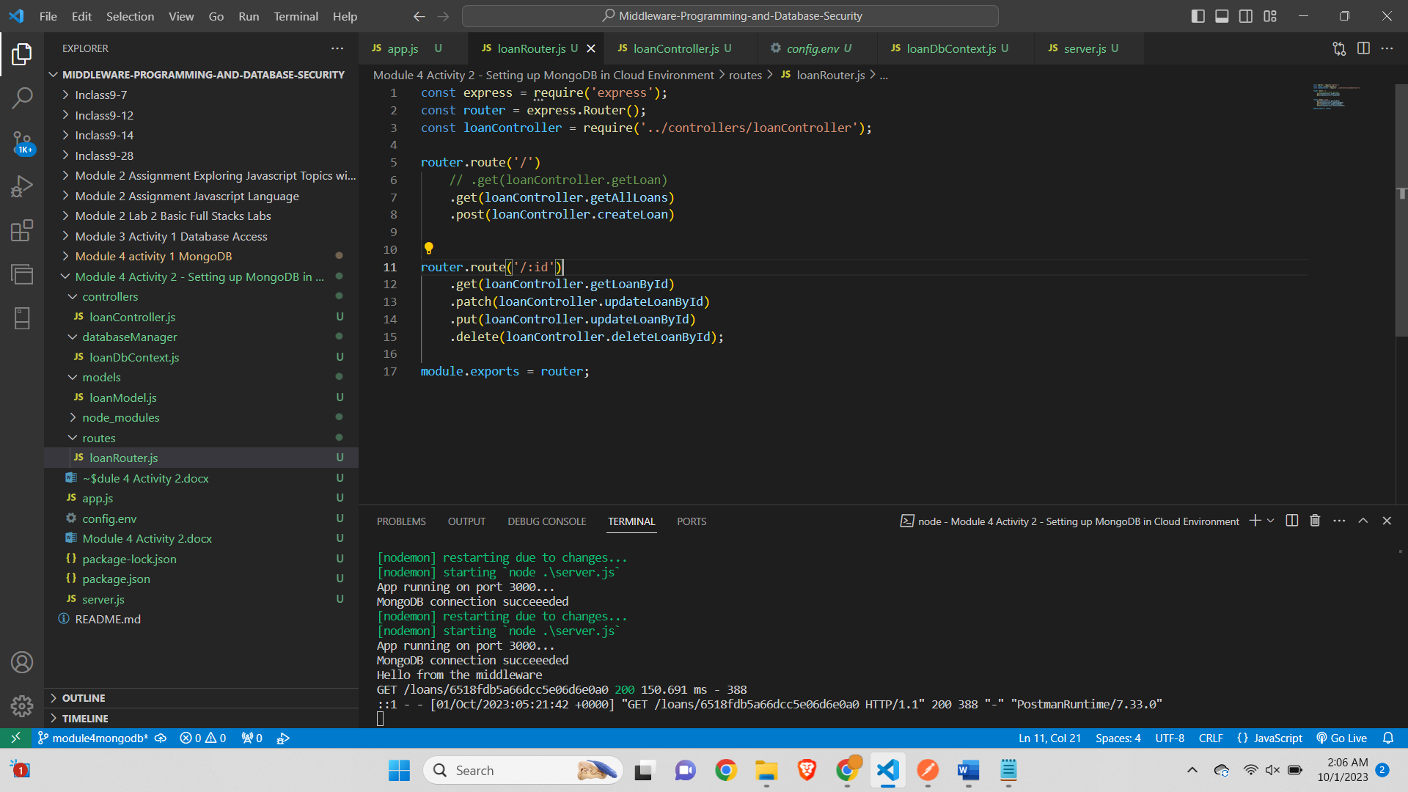

Screenshot of the **loanController.js** file

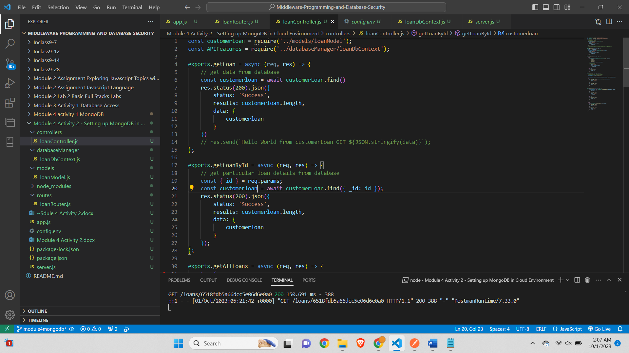

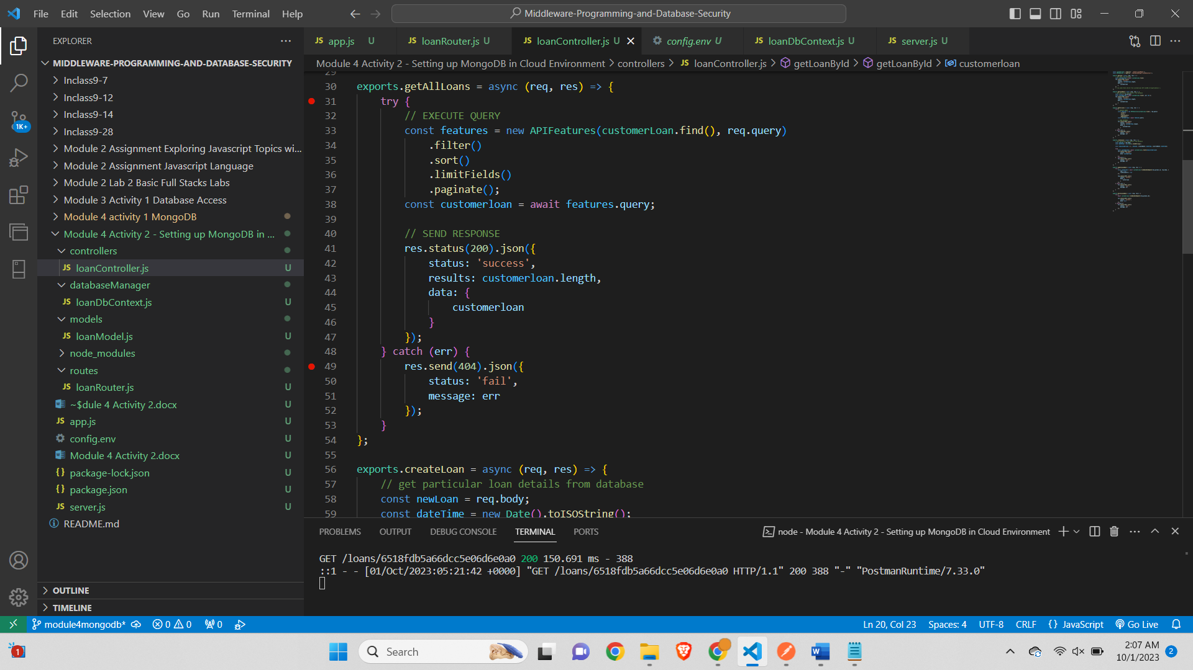

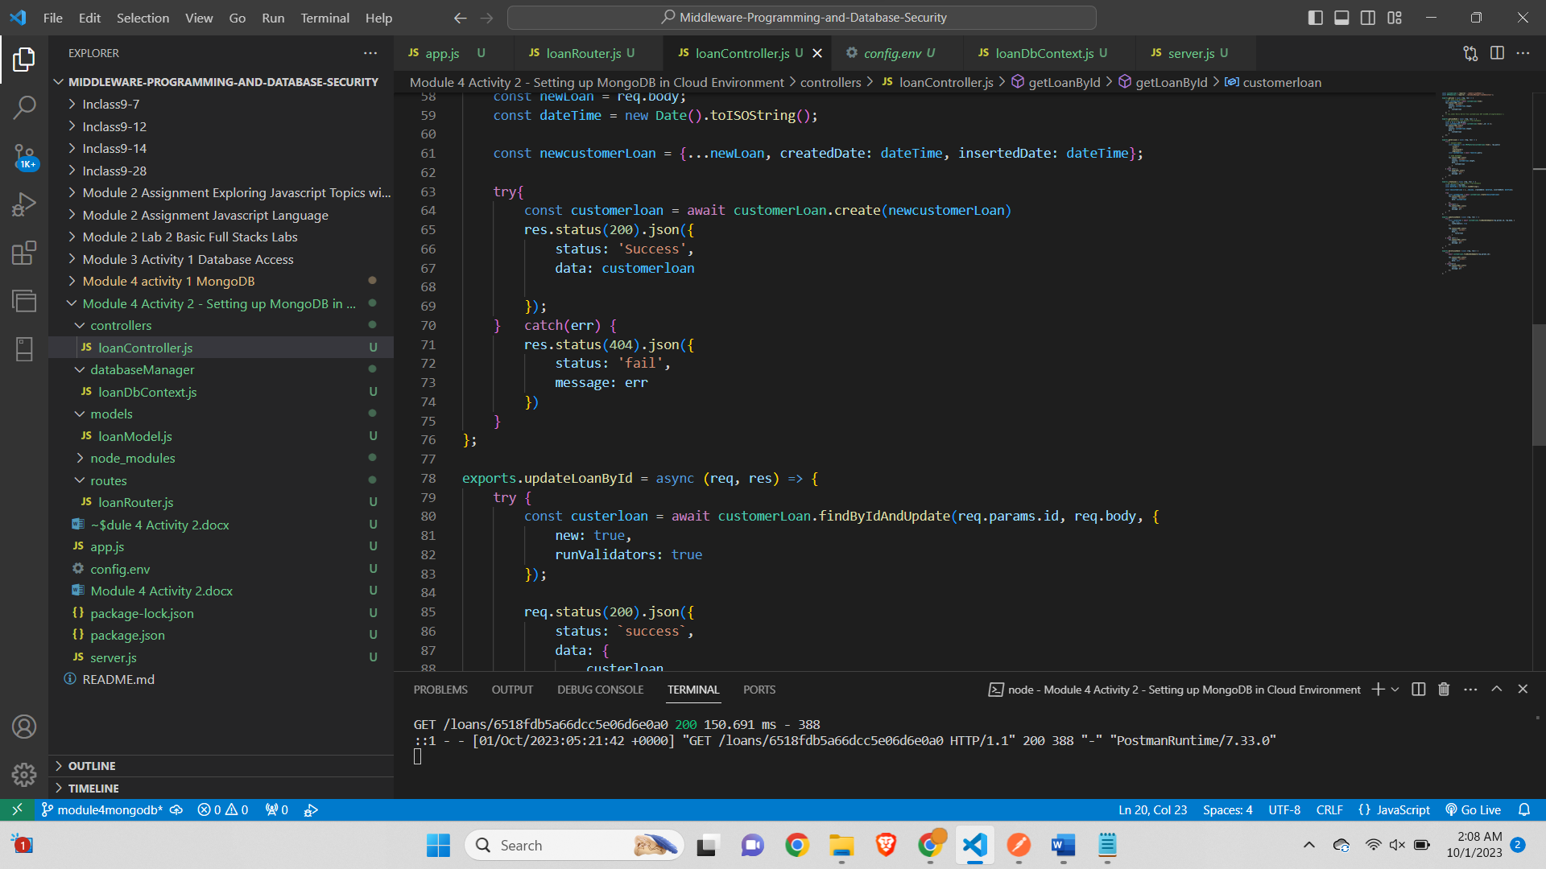

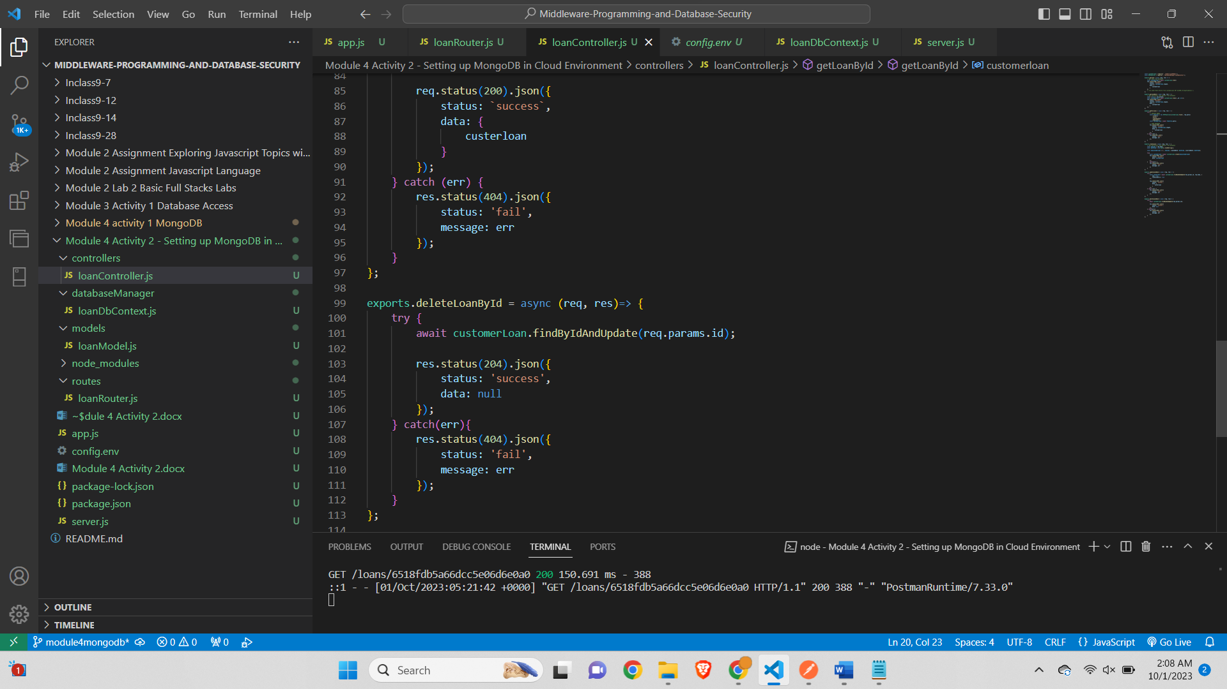

**Screenshot of loanModel.js file-**

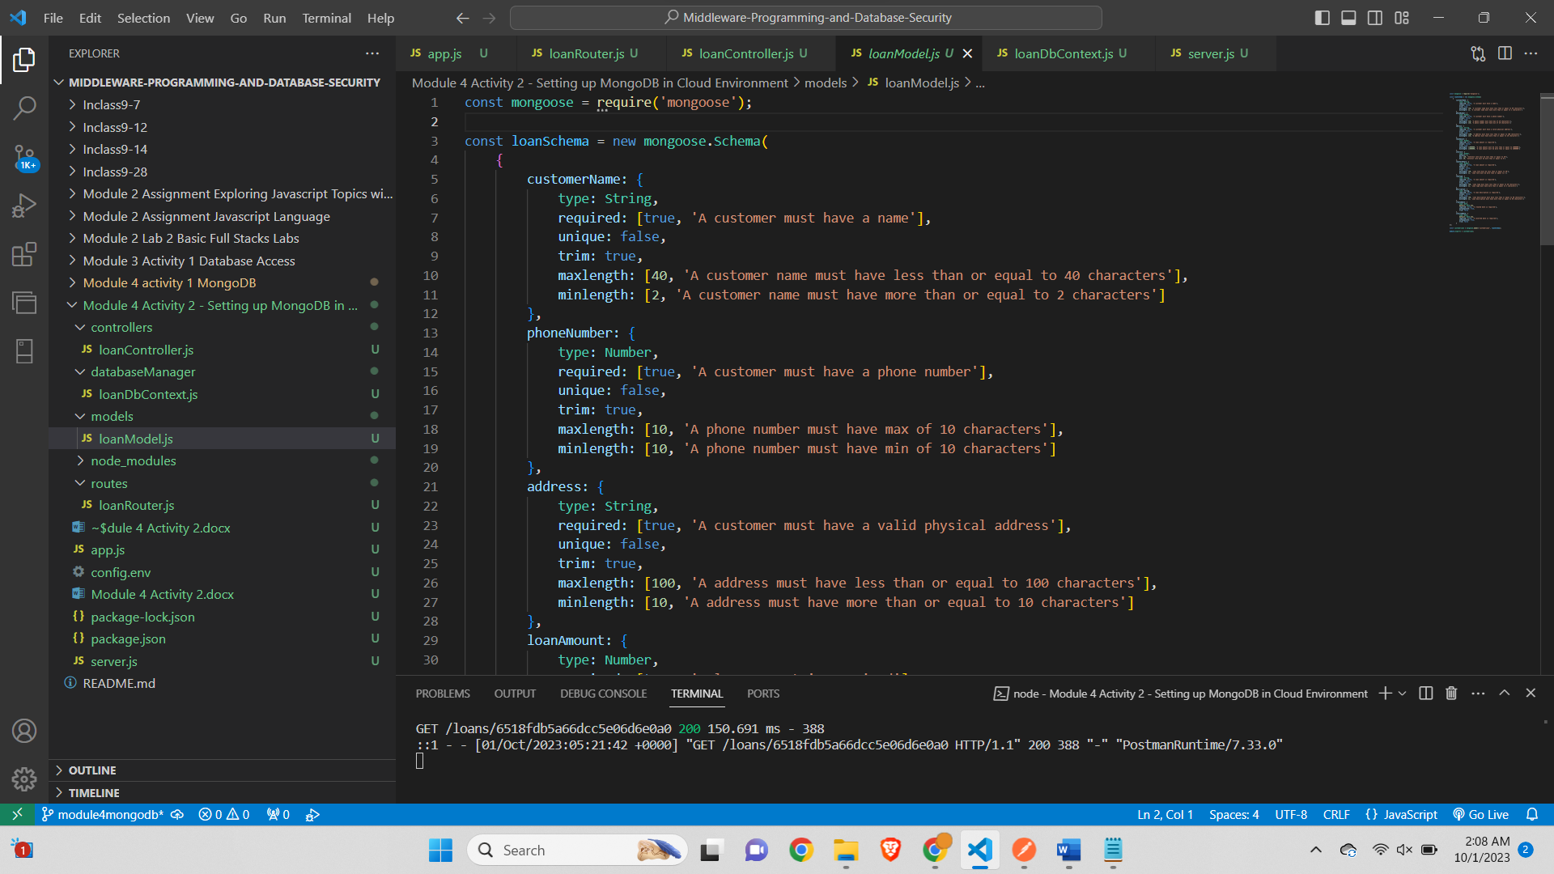

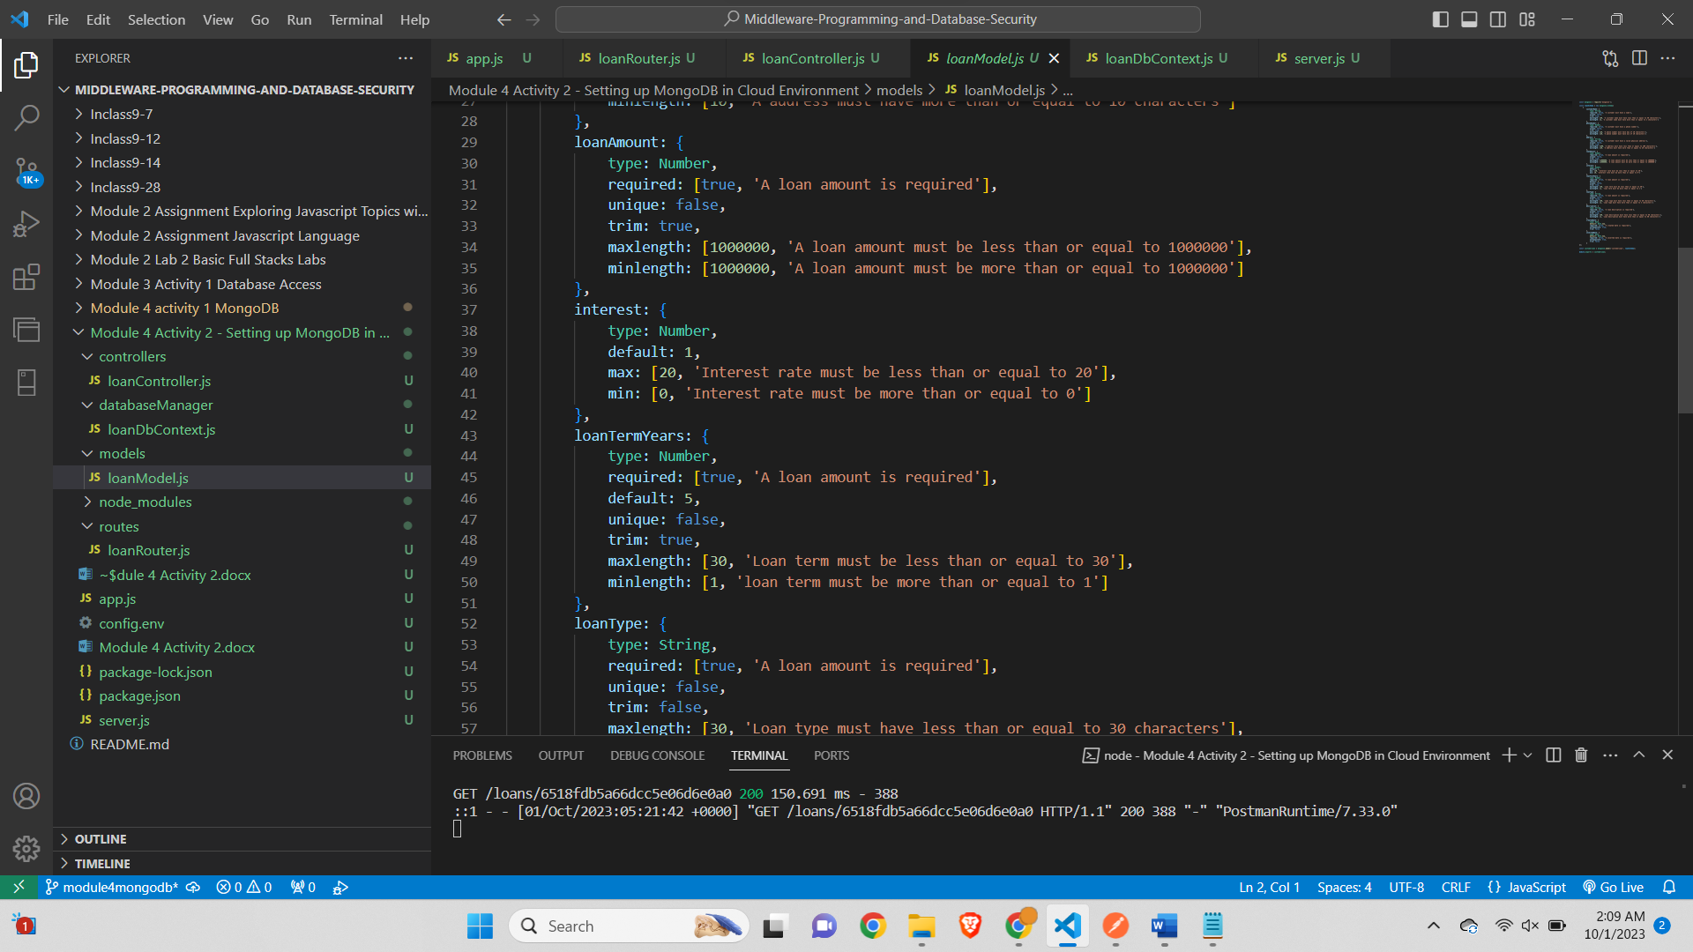

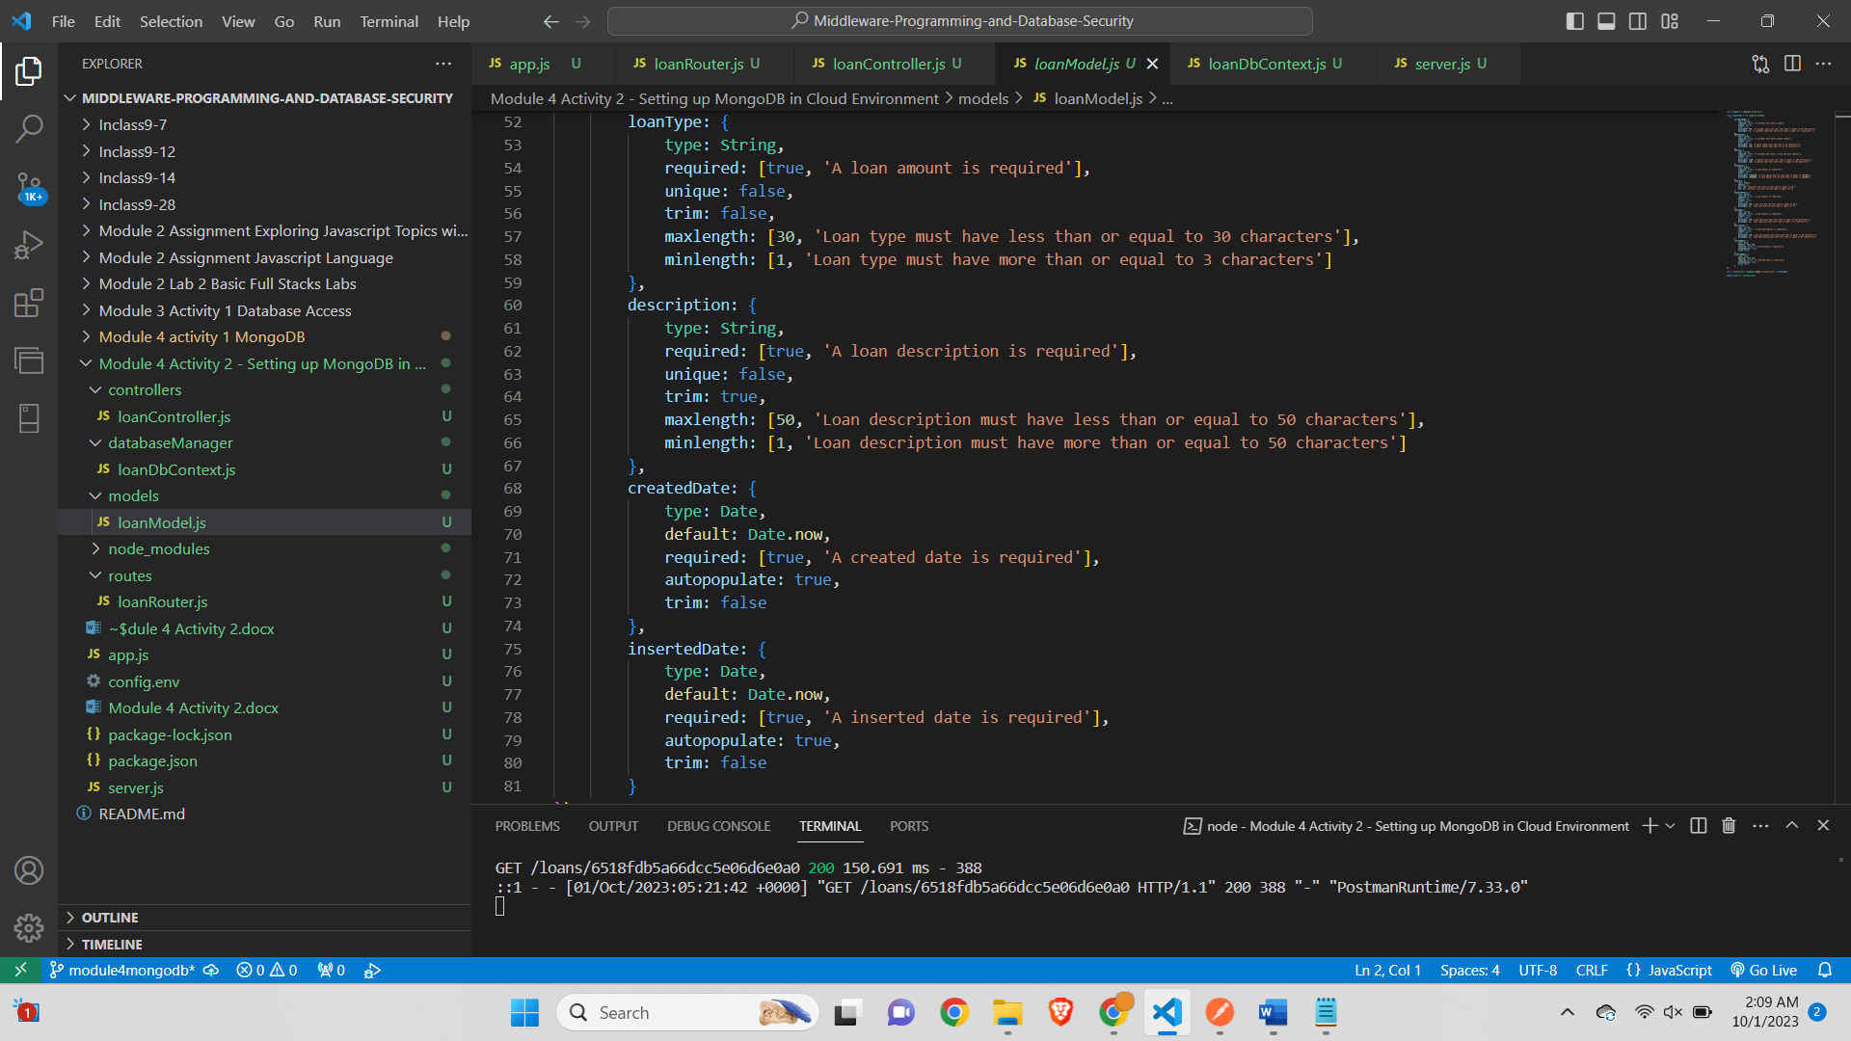

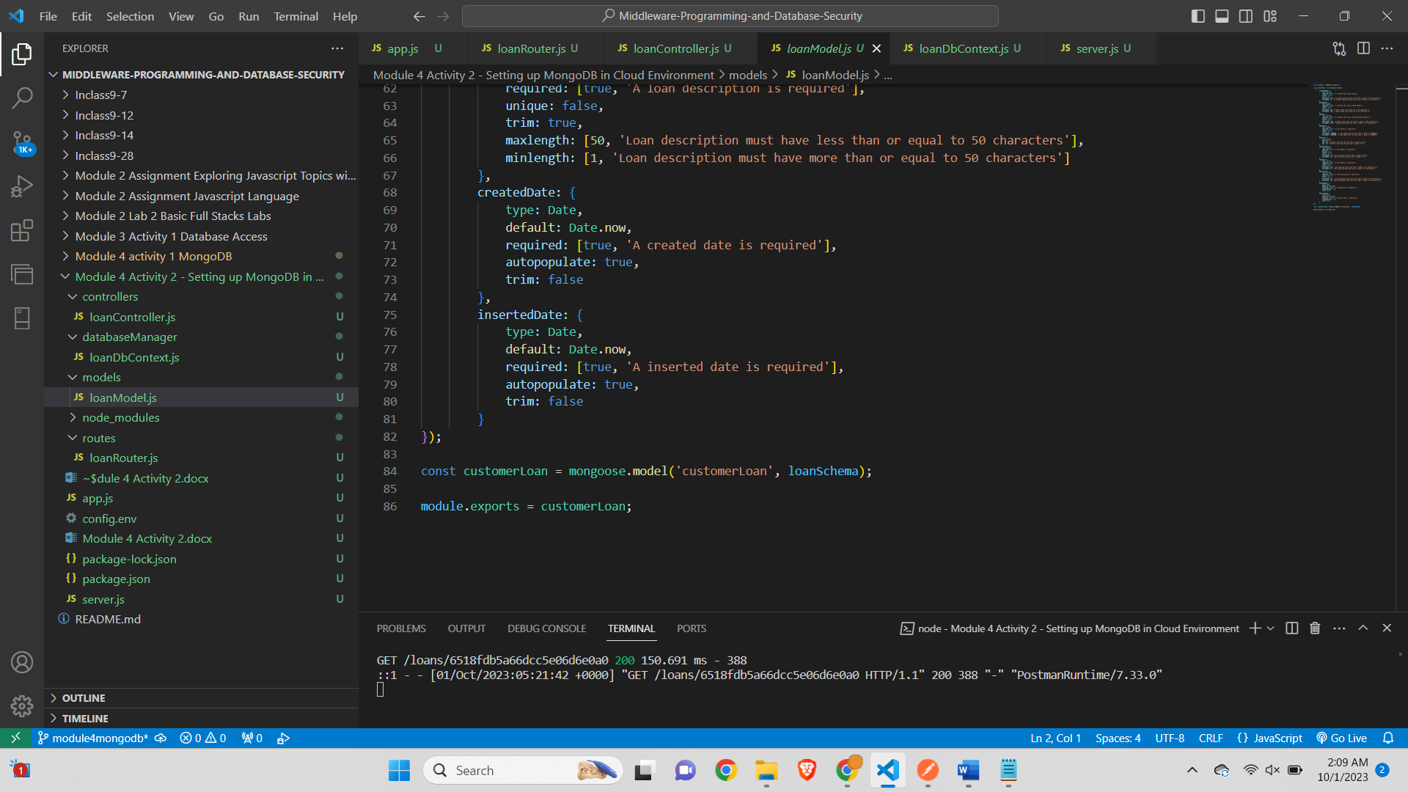

**Step 3 – Server.js file**

**Screenshot of the server.js file-**

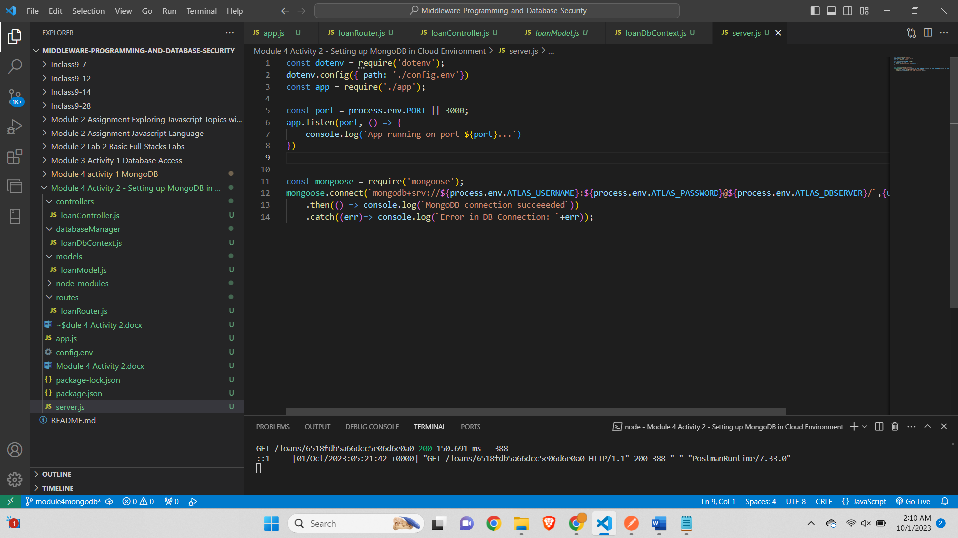

**Step 4 – Create a folder and name it as dataBaseManager**

*Screenshot of the dataBaseManager folder and the loanDbContext.js file*

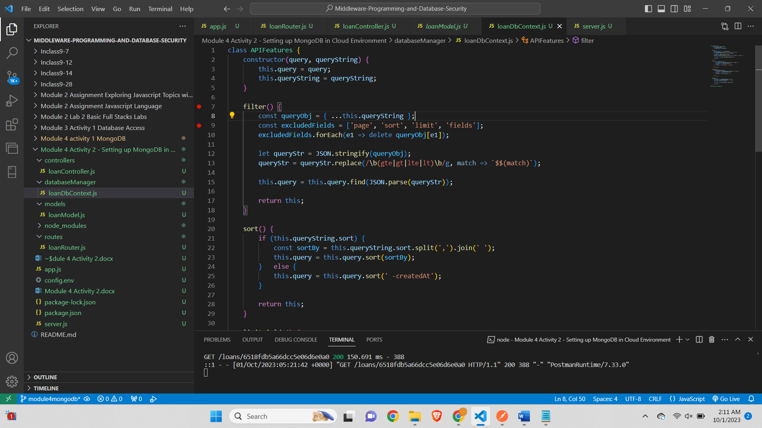

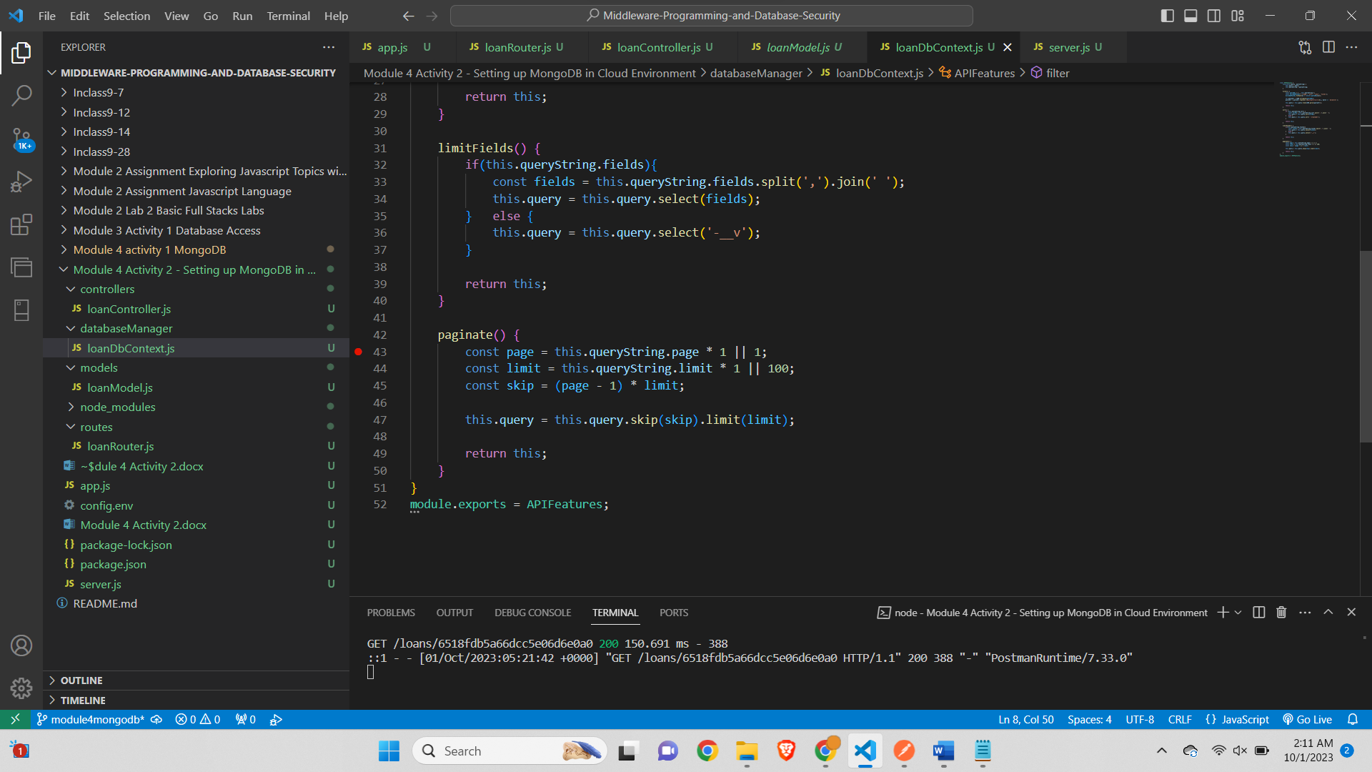

**Step 5 – Controller file**

***Screenshot of the loanController.js***

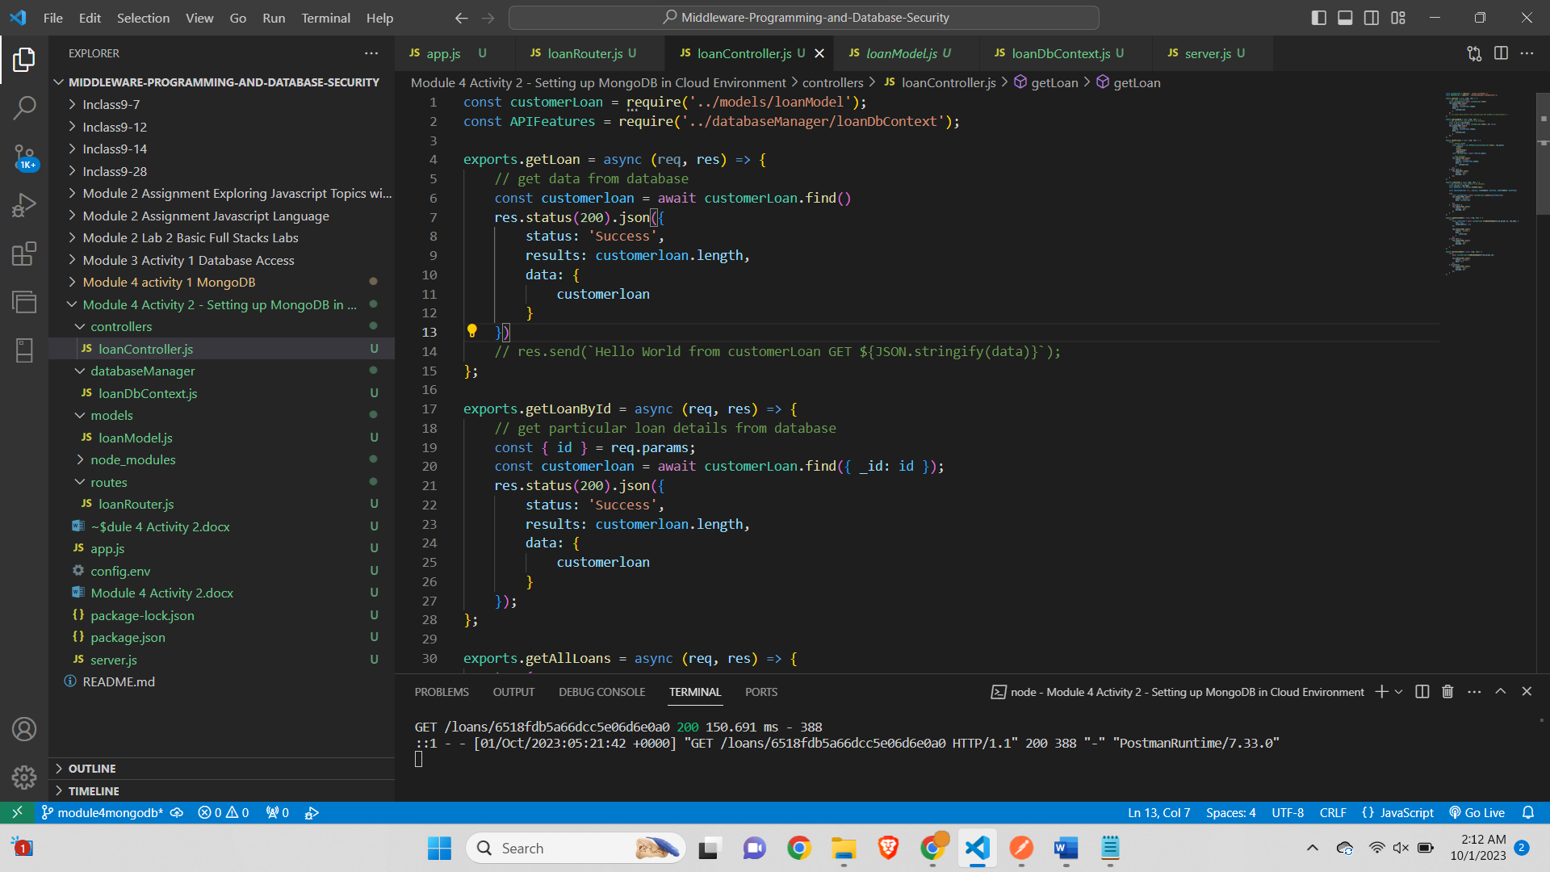

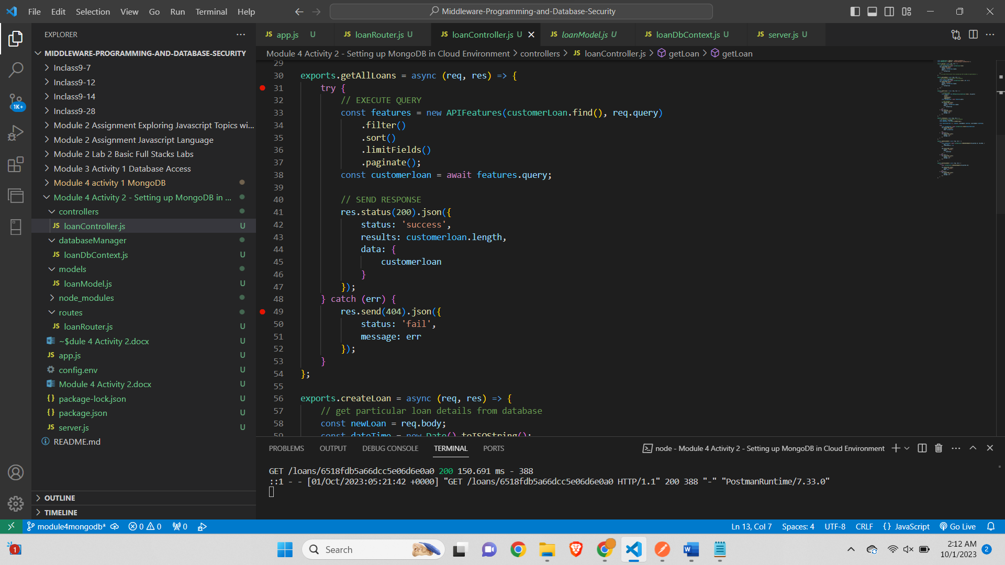

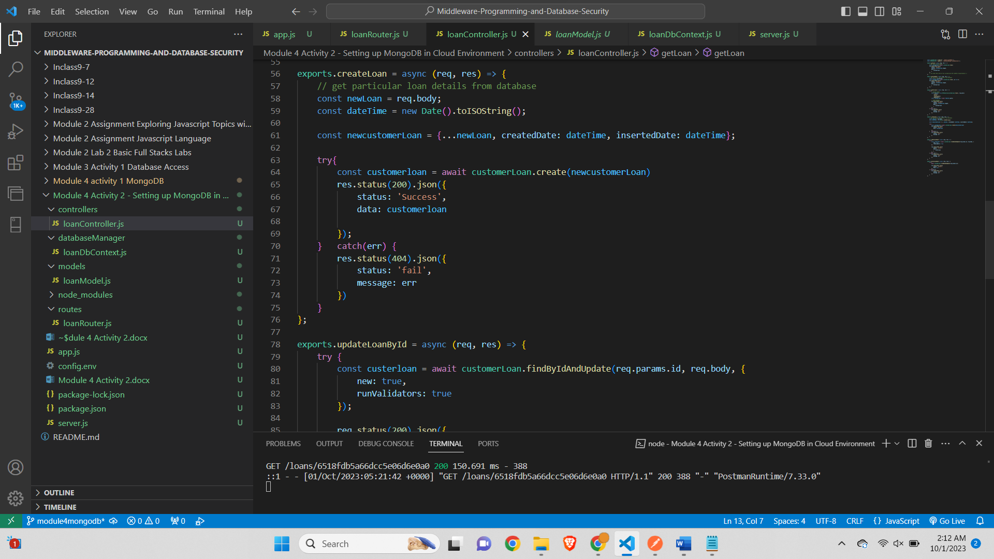

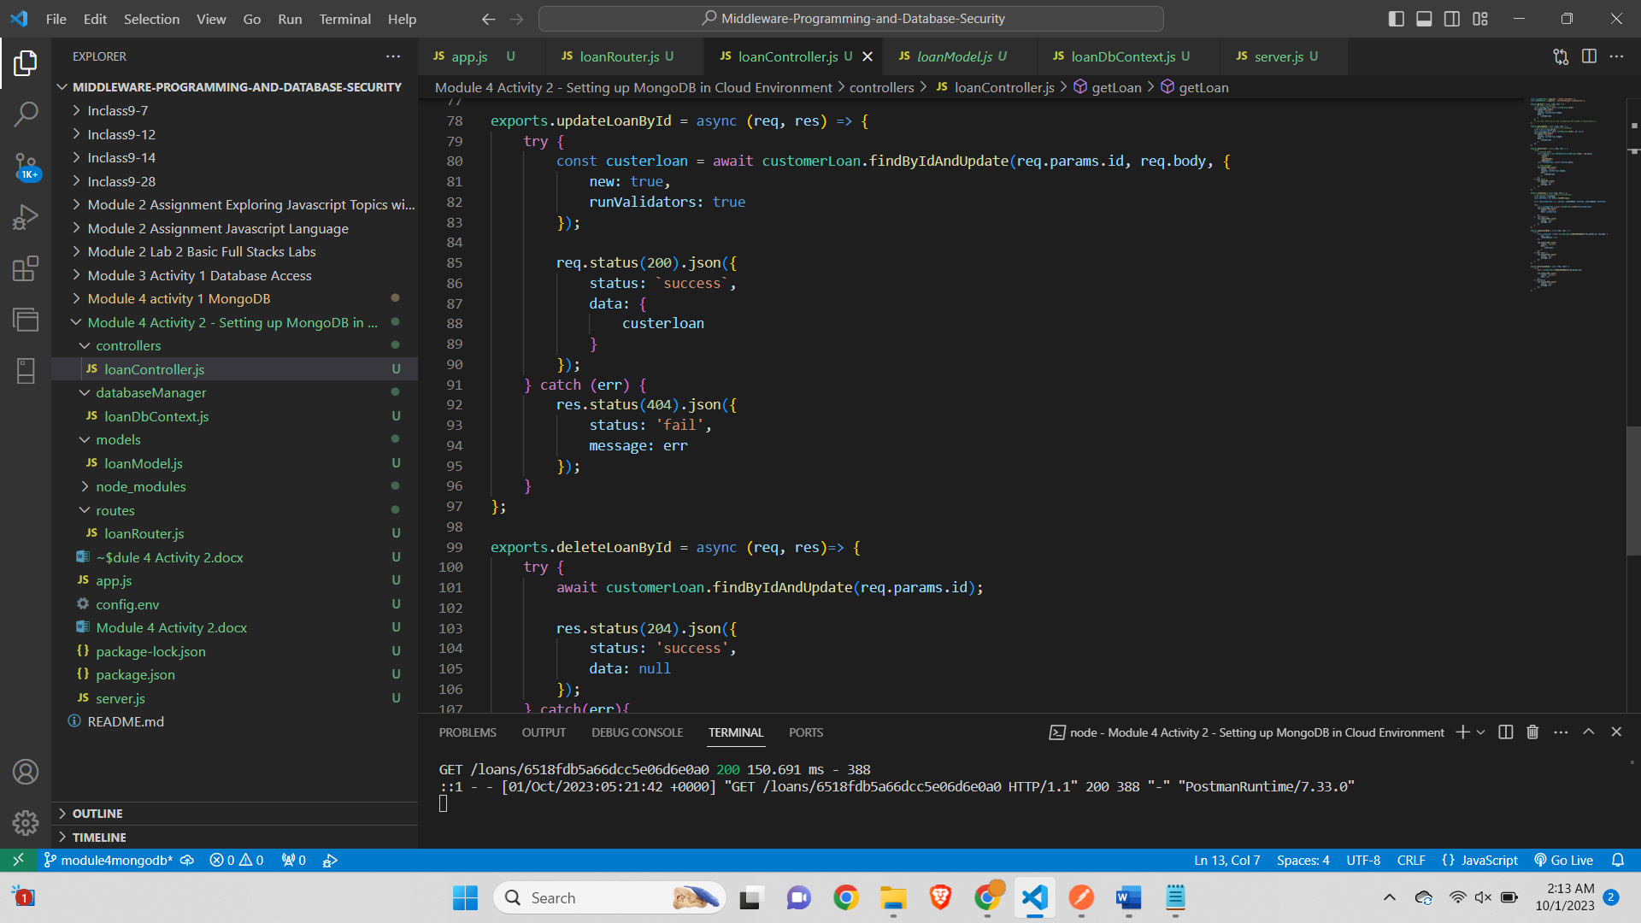

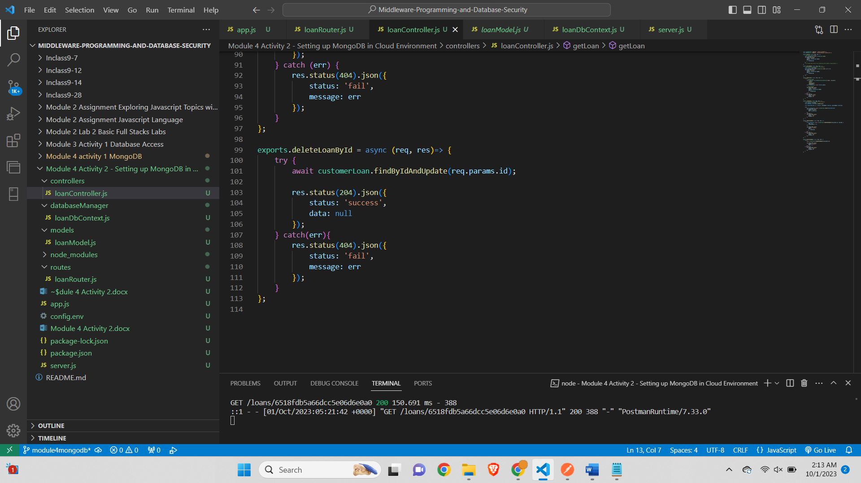

**Step 6 – App.js file**

*Screenshot of the app.js file*

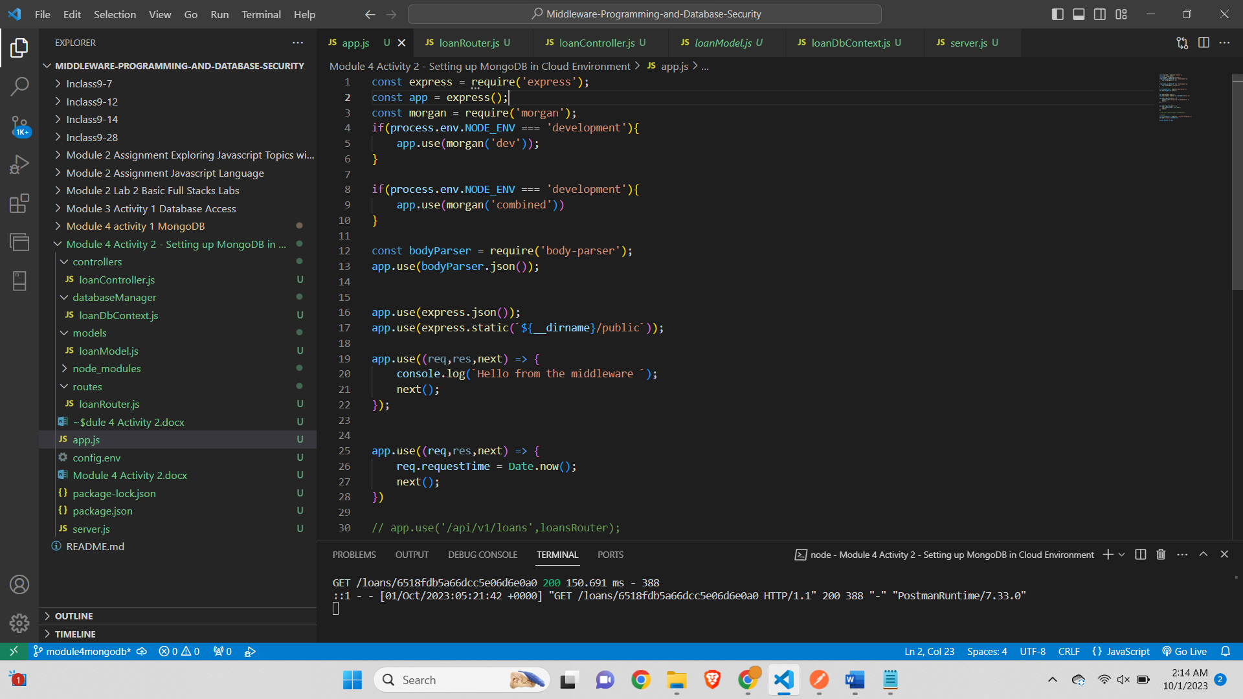

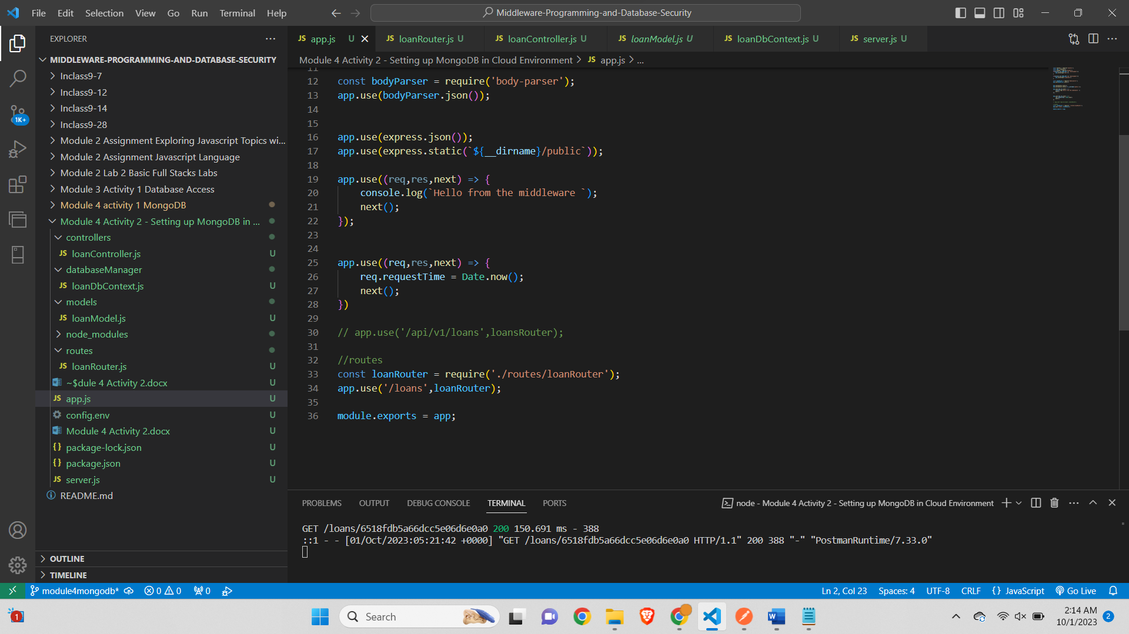

**Step 7 – The App ran displaying the PORT number and LISTEN Message**

*Screenshot of the output displaying the port number and the message showing the DB connection successful*

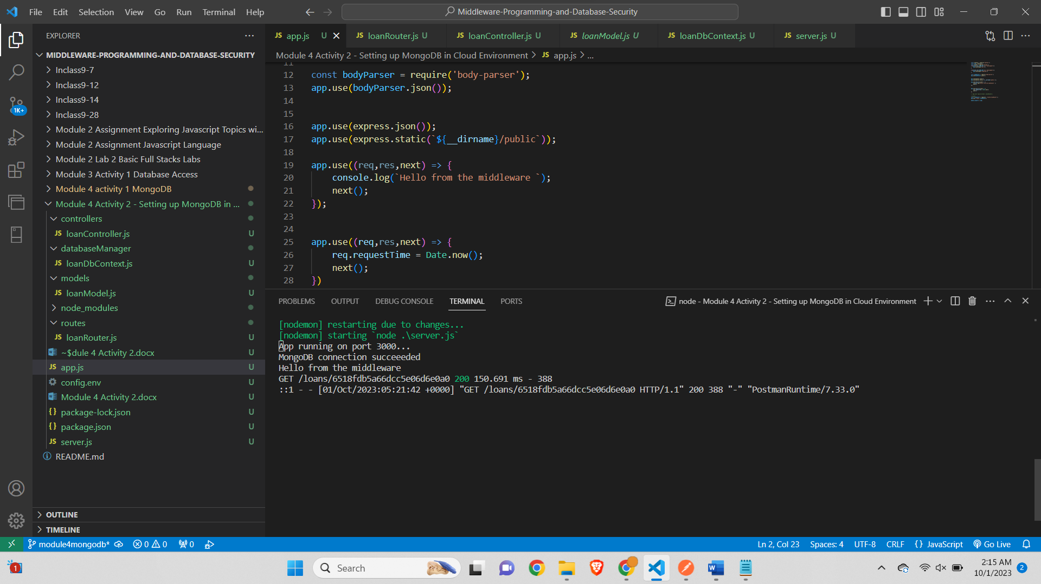

**Step 8 – Add a new loan (POSTMAN).**

*Screenshot of the postman showing the addition of new loan successfully*

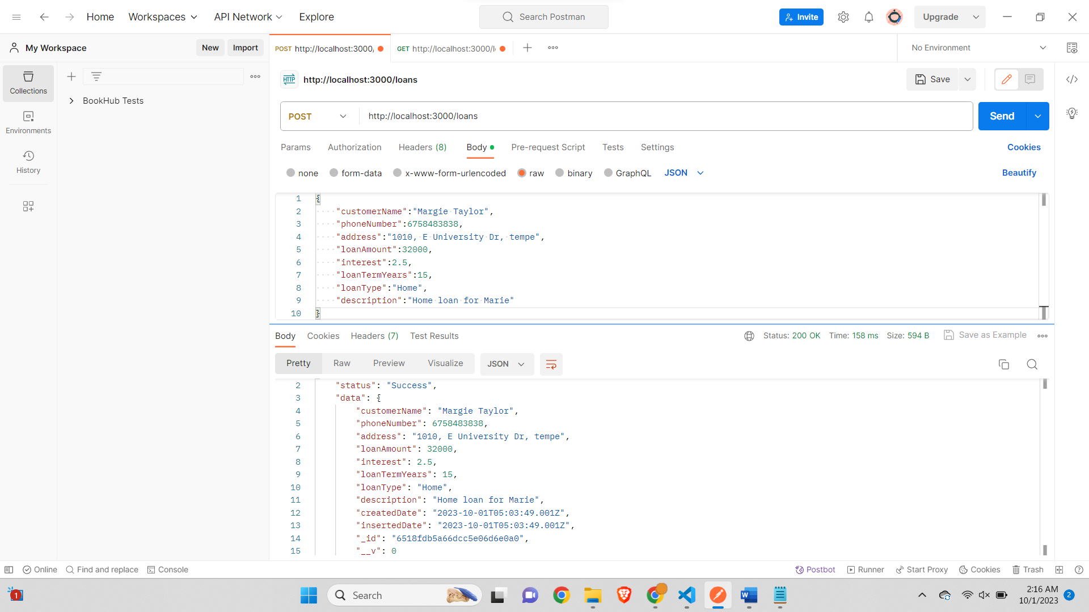

**Loan document successfully added to the Mongo DB**

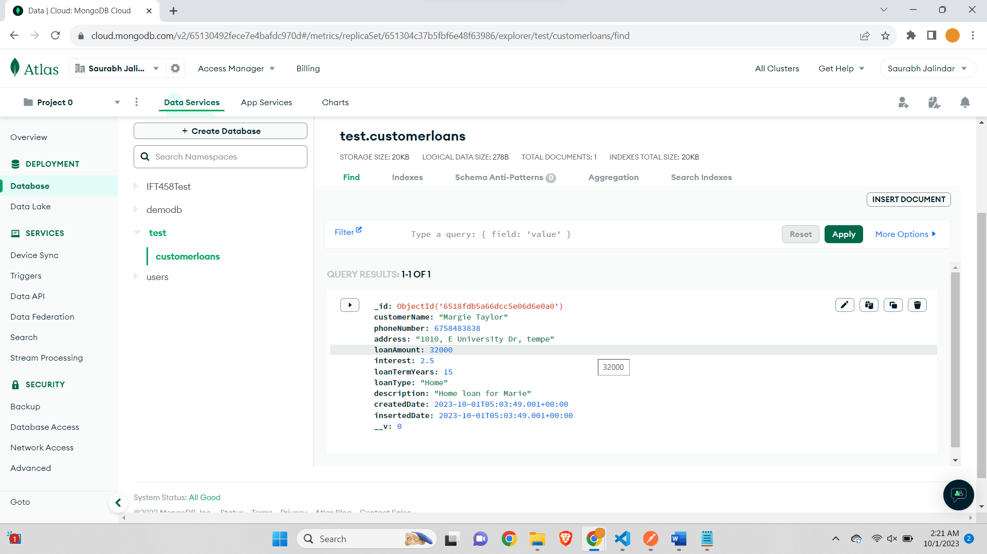

**Step 9 – Add 5 additional loans (POSTMAN).**

*Screenshot of the postman showing successful addition of 5 new loans*

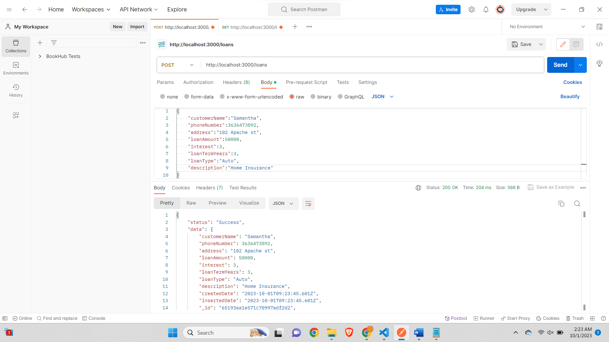

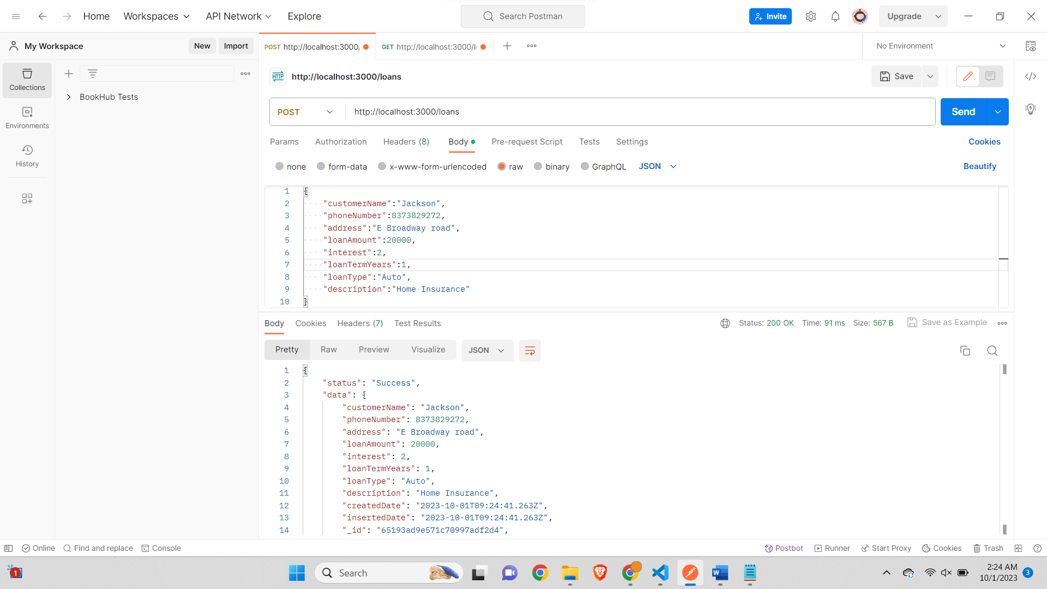

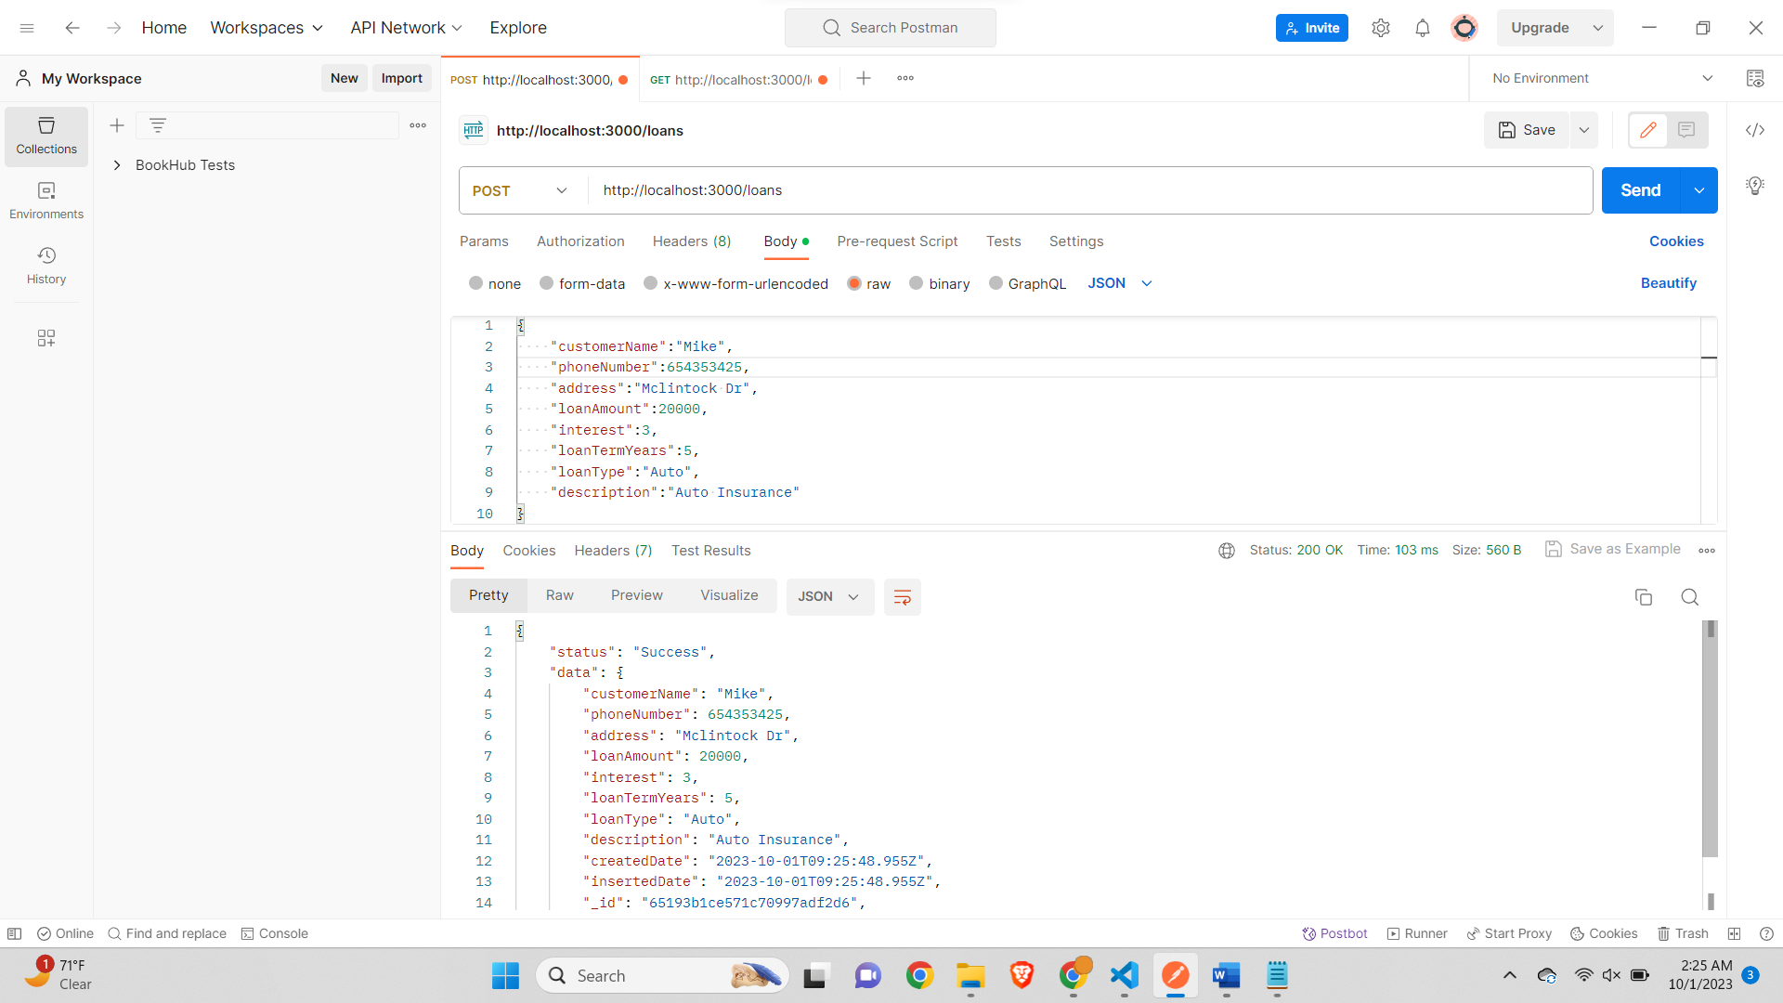

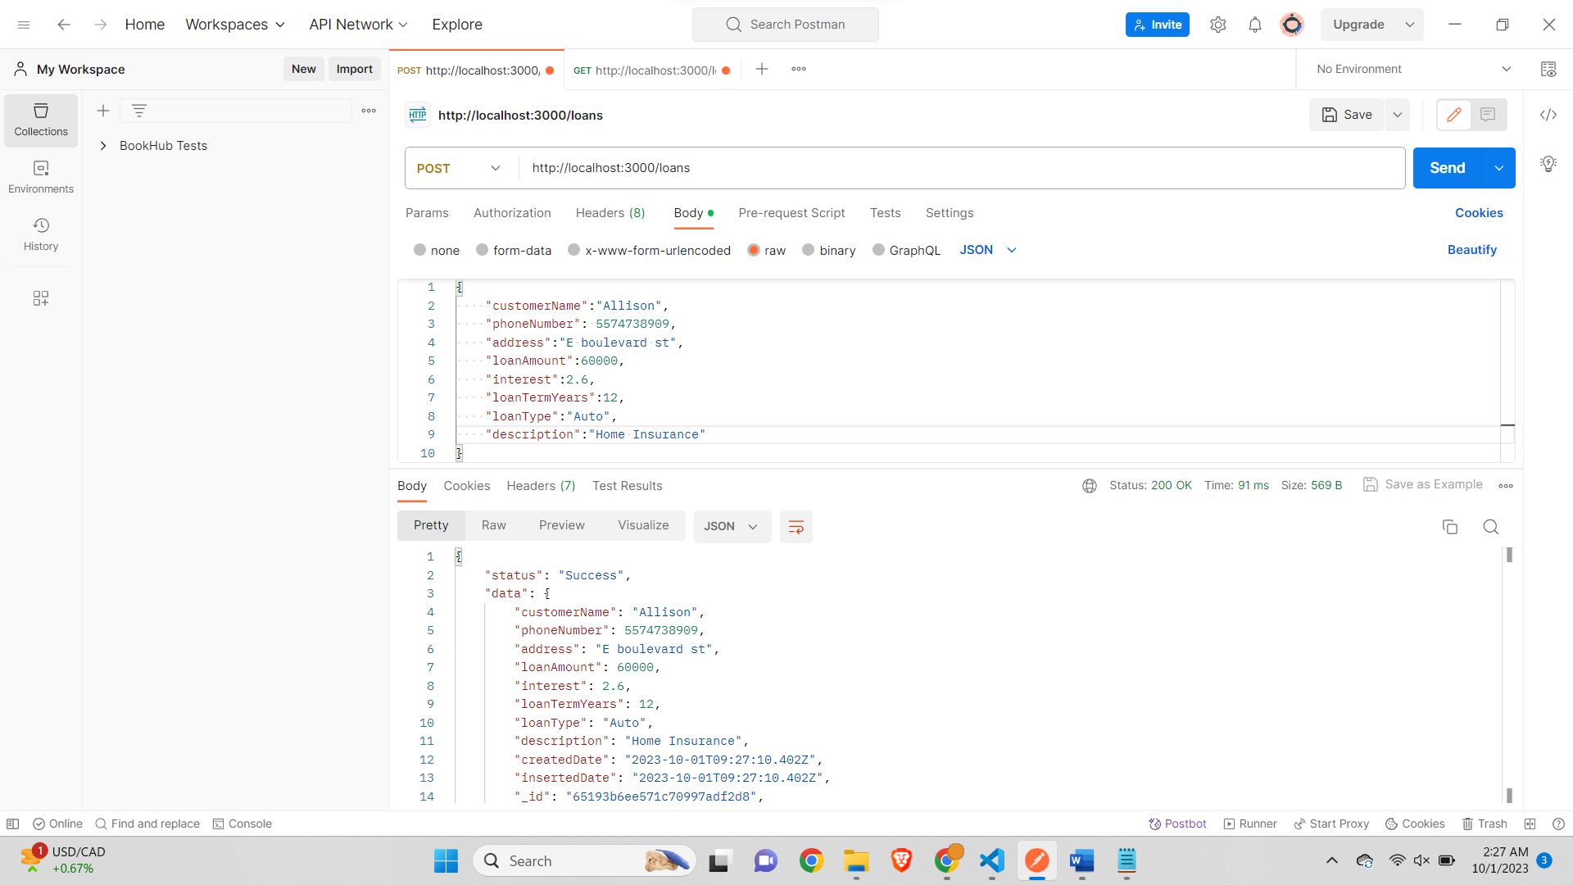

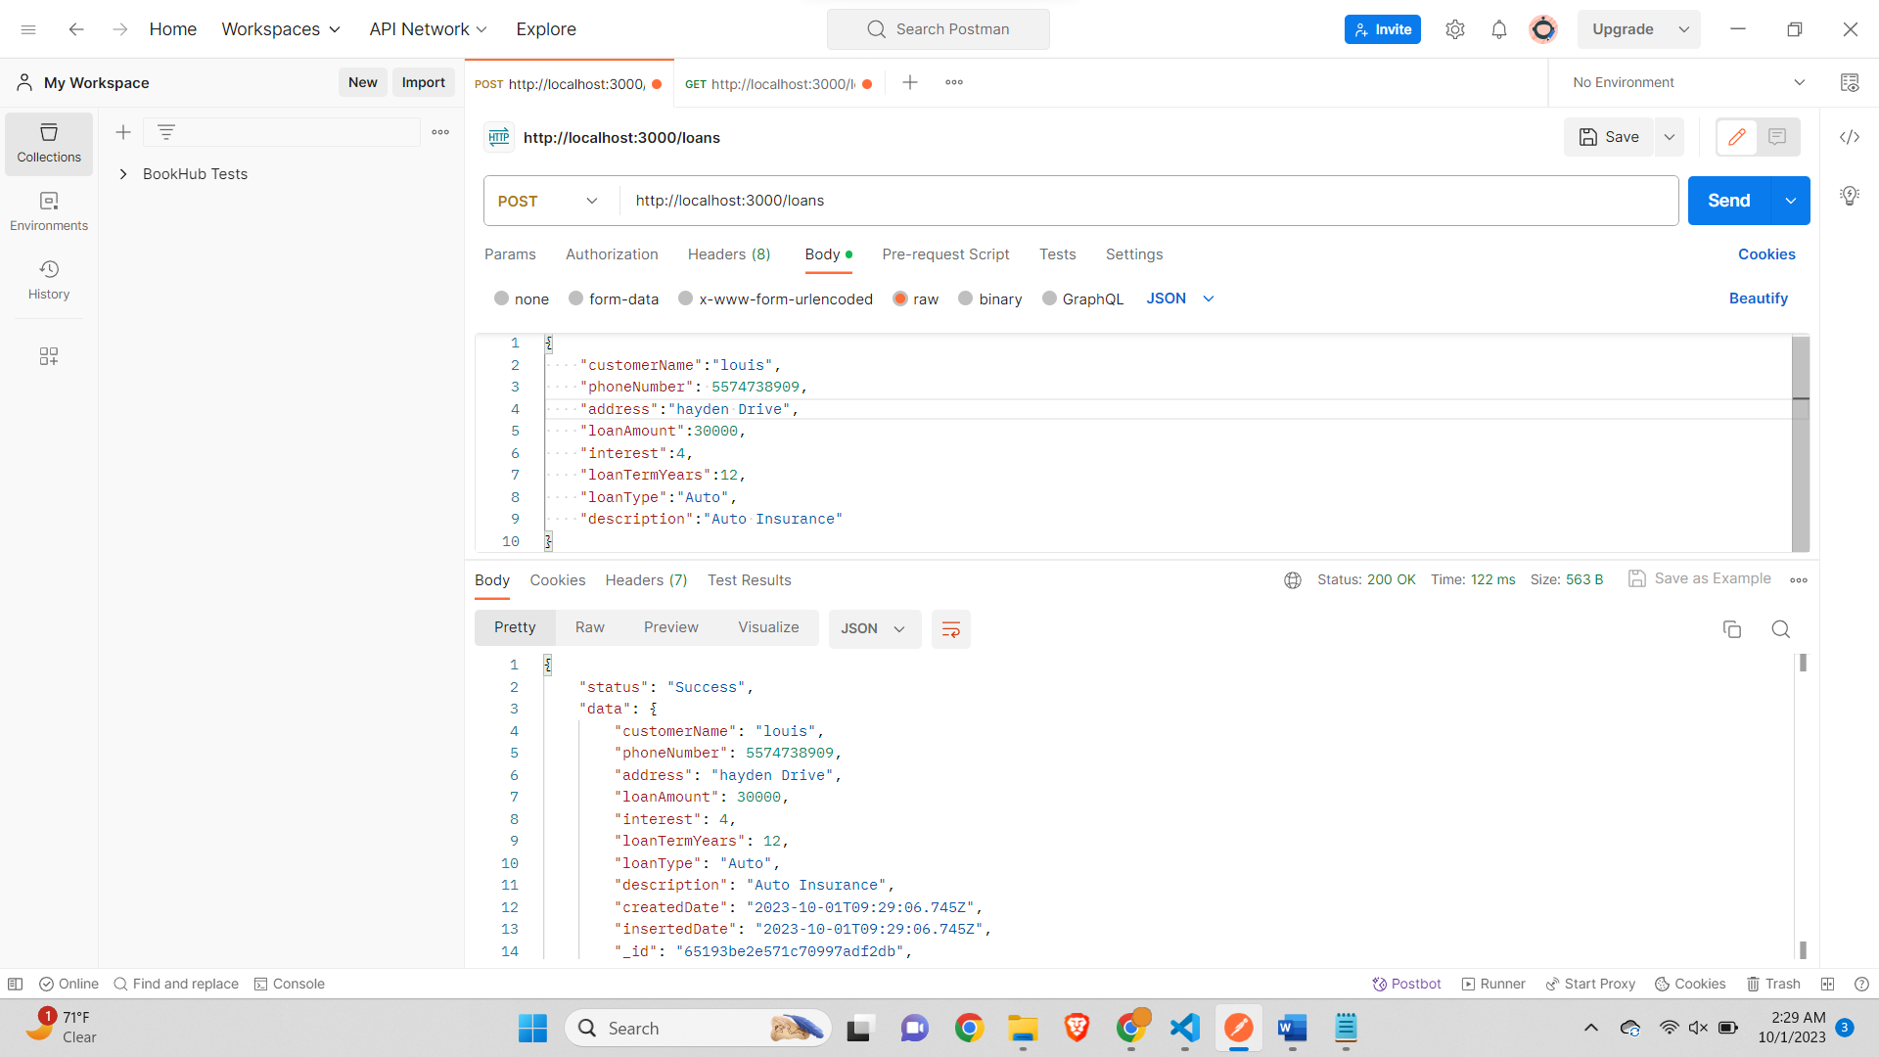

*Screenshot of the Terminal output*

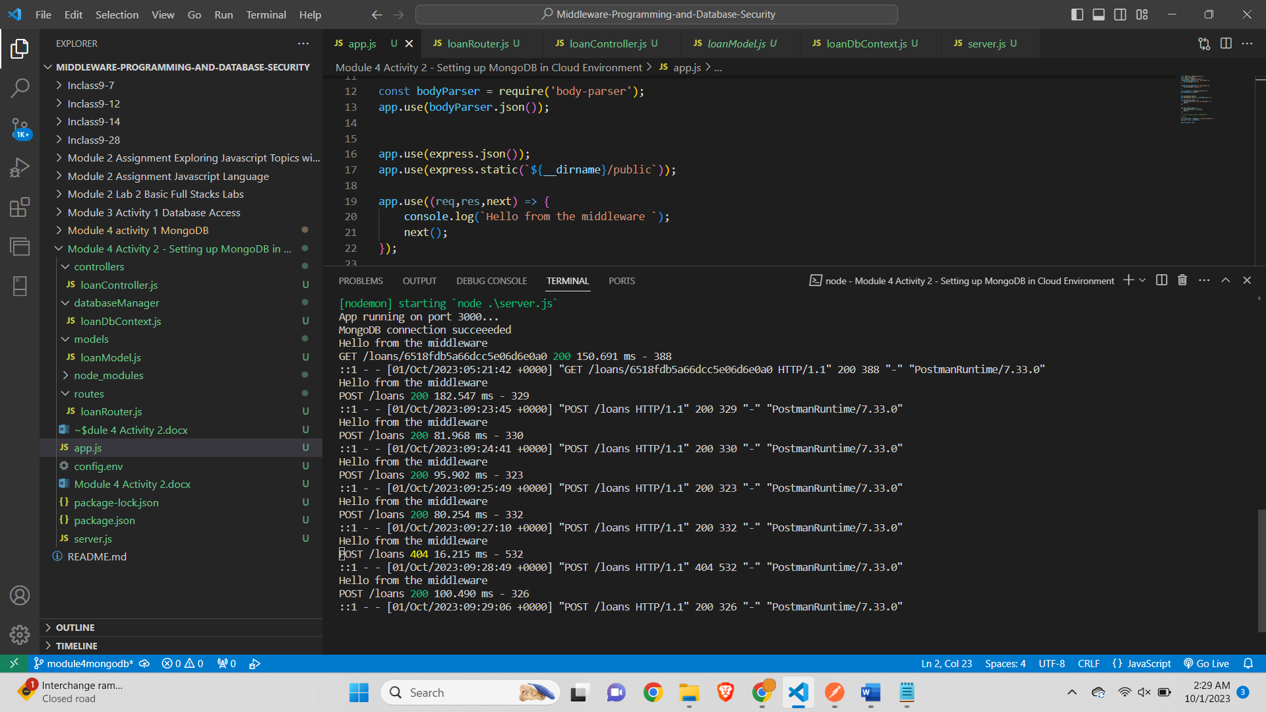

***Screenshot of the MongoDB Atlas showing successful addition of the 5 loans***

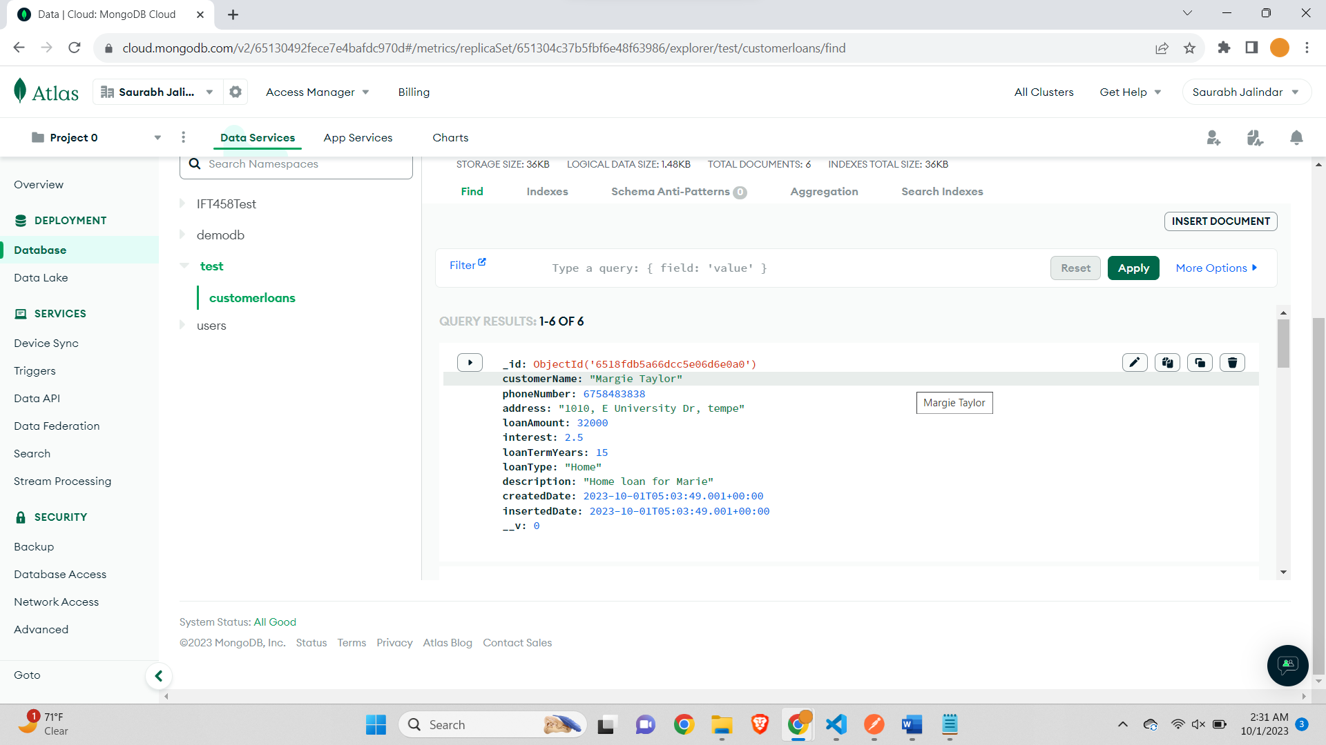

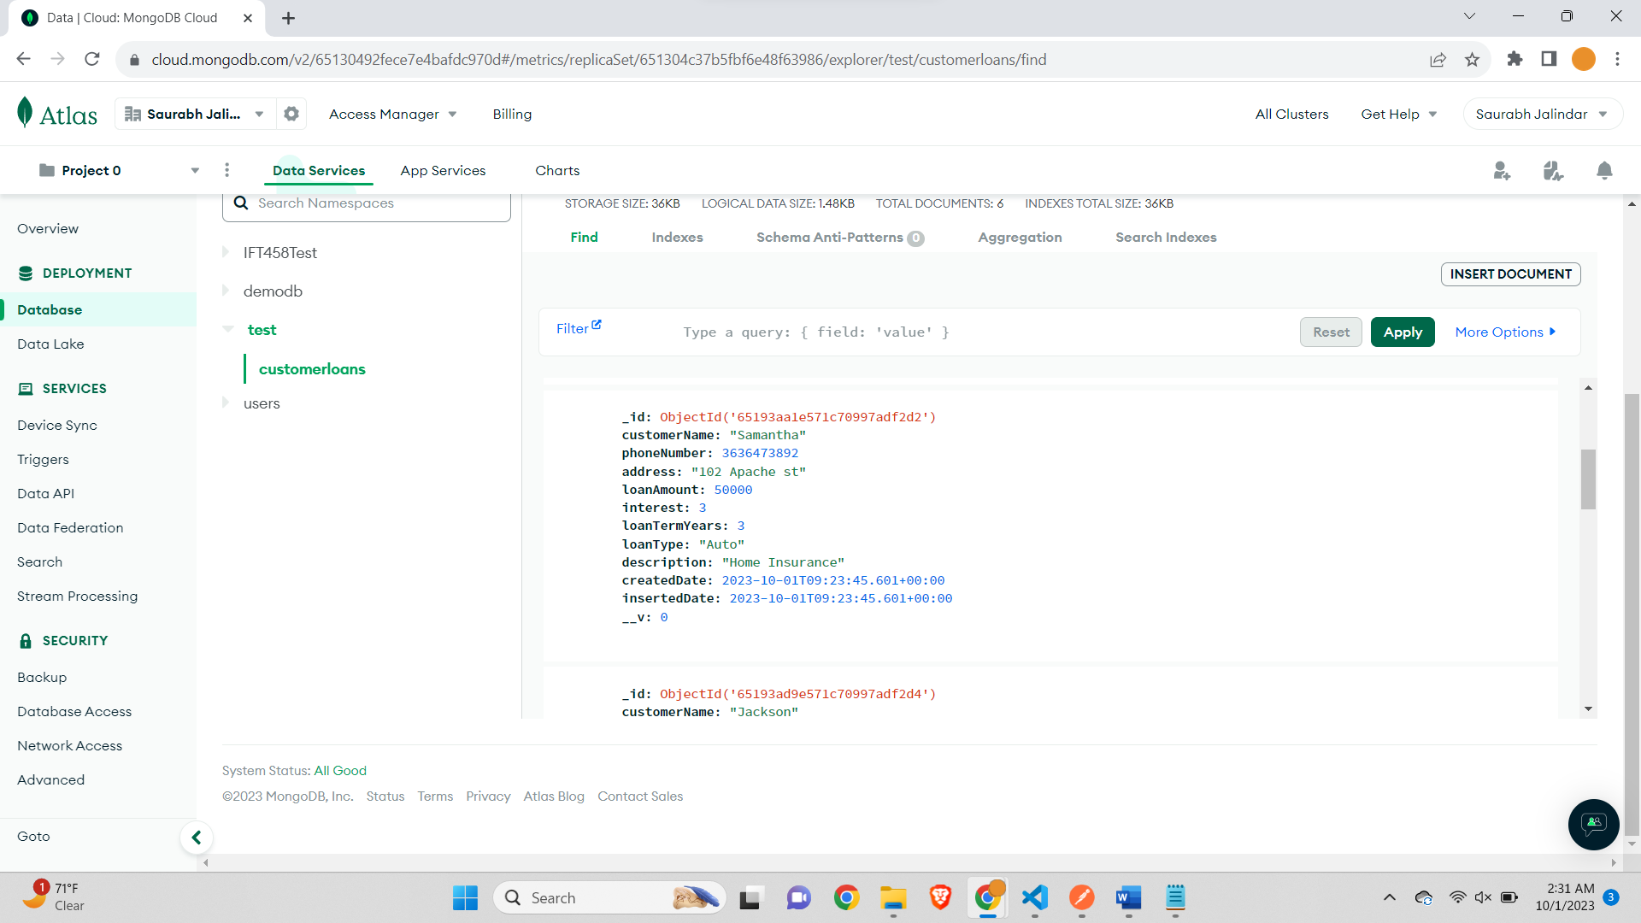

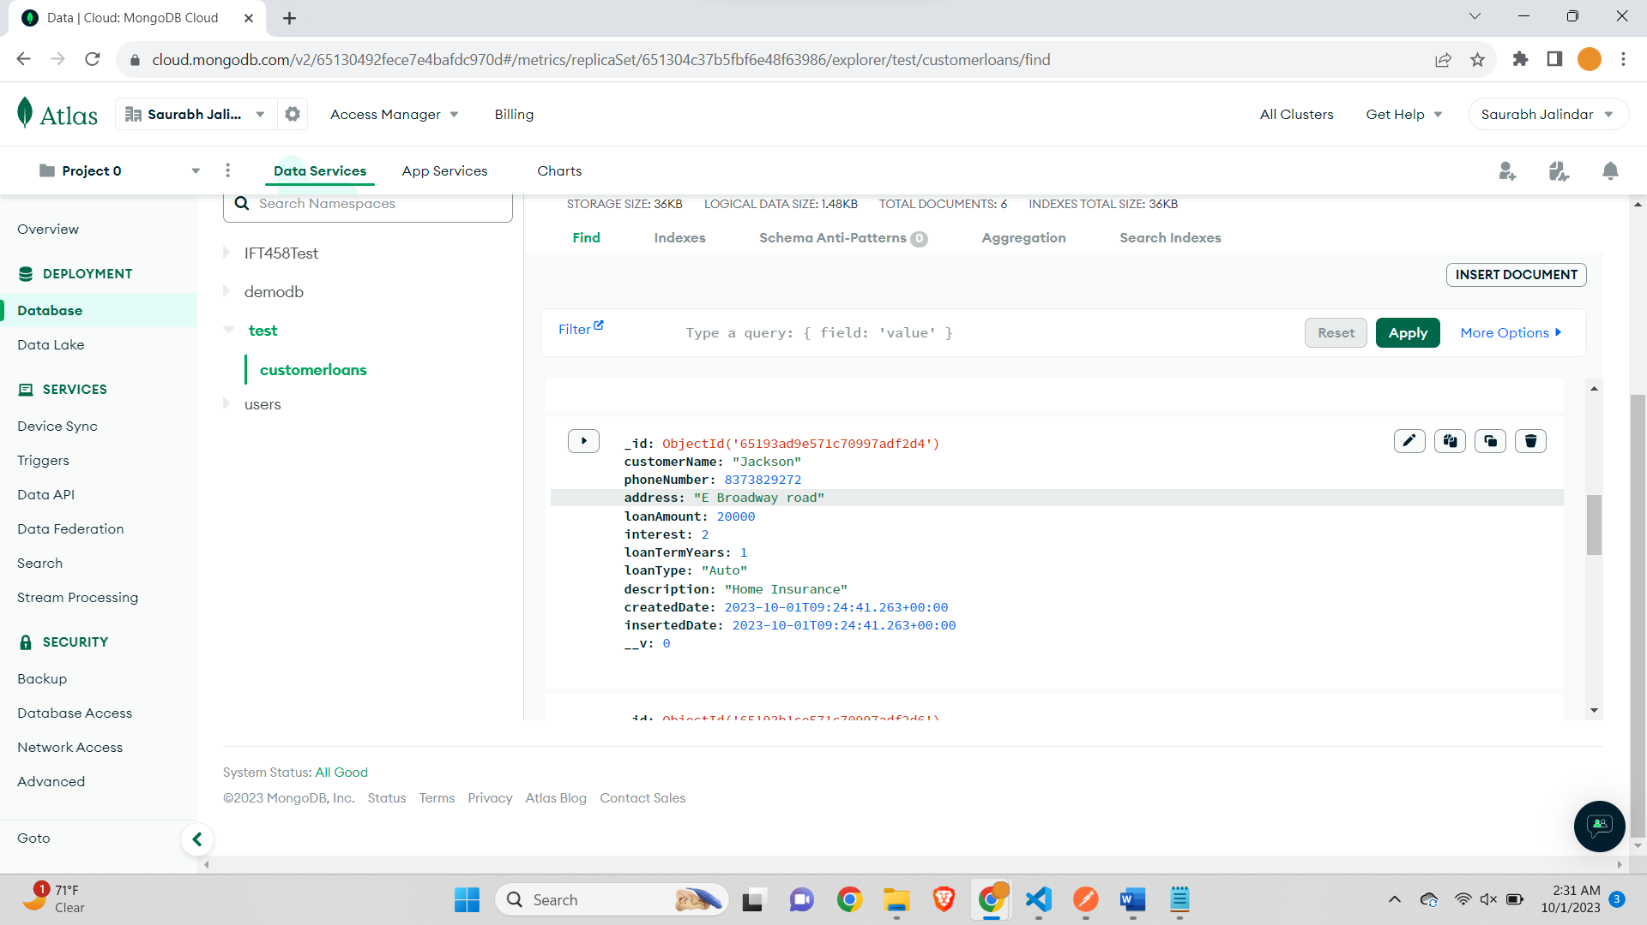

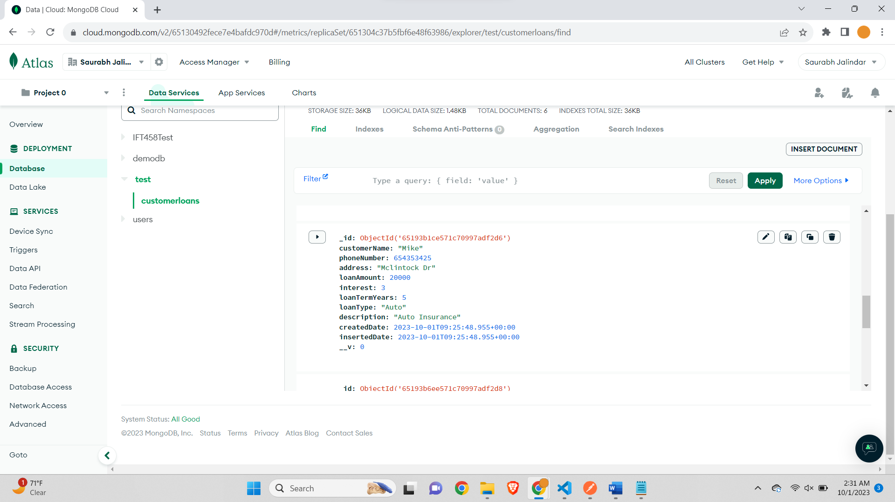

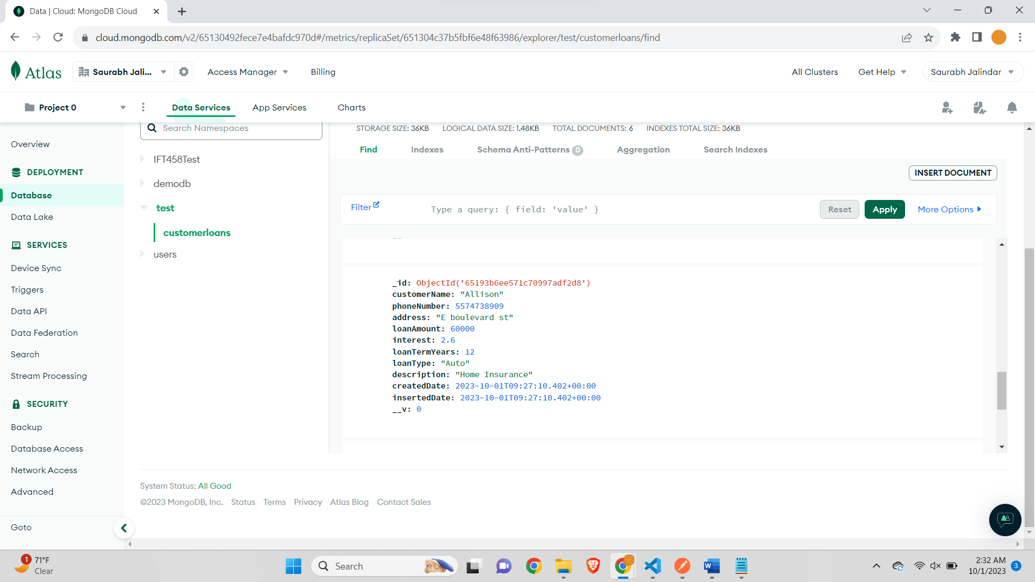

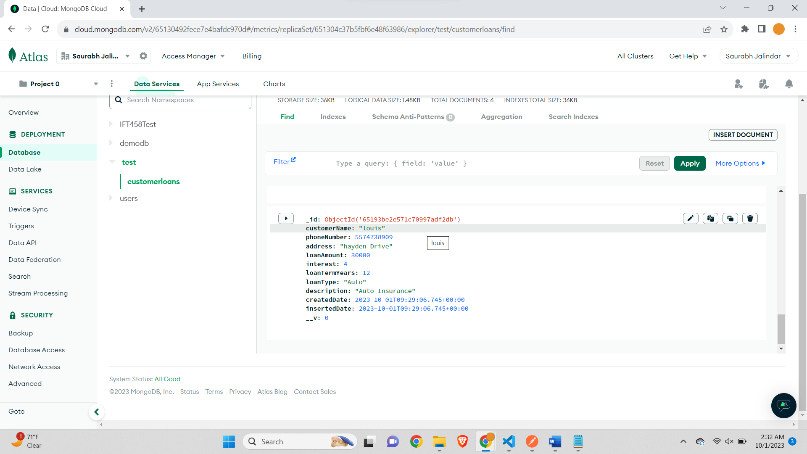

**Step 10 – Get Users To get all users, enter http://localhost:<PORT-NUMBER>/loans/ as the address.**

*Screenshot of the Postman and MongoDB Atlas showing all Customers*

*All 6 documents from the collection are successful via the /loans end point as shown below –*

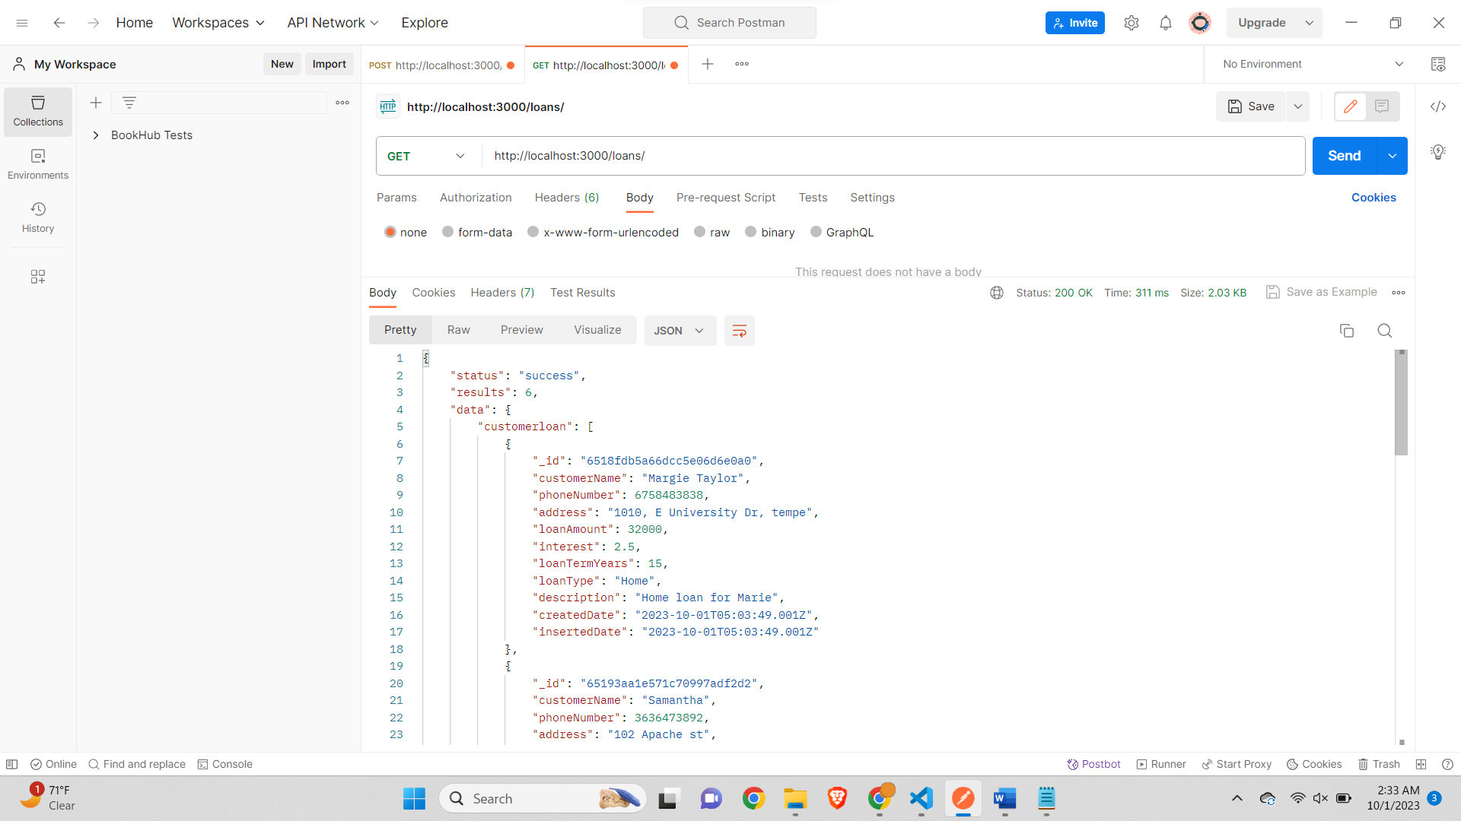

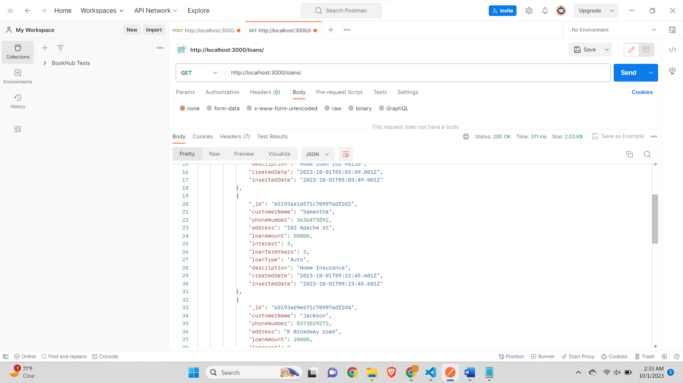

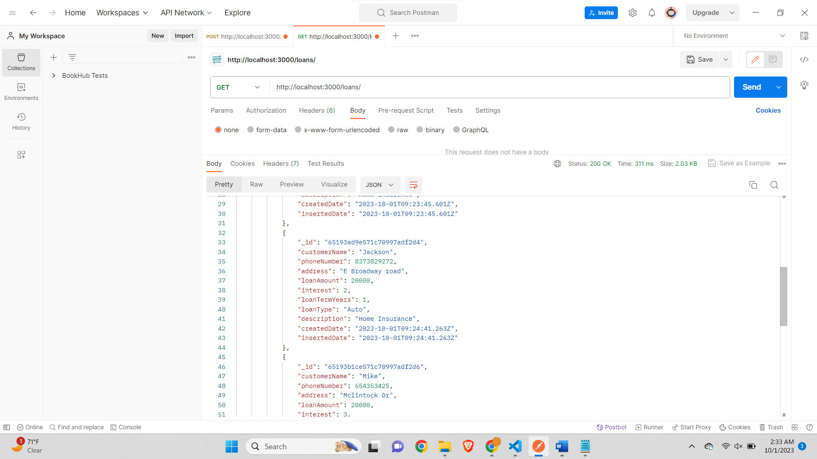

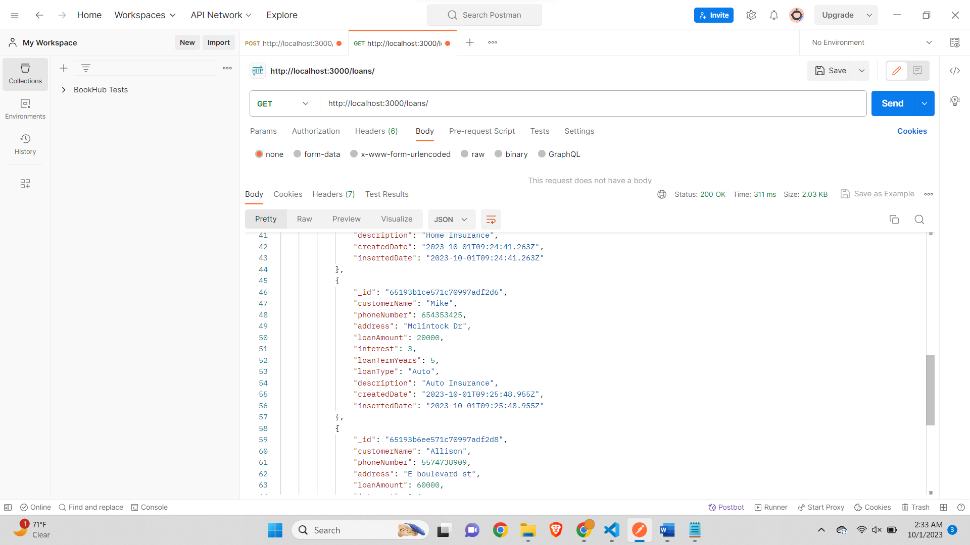

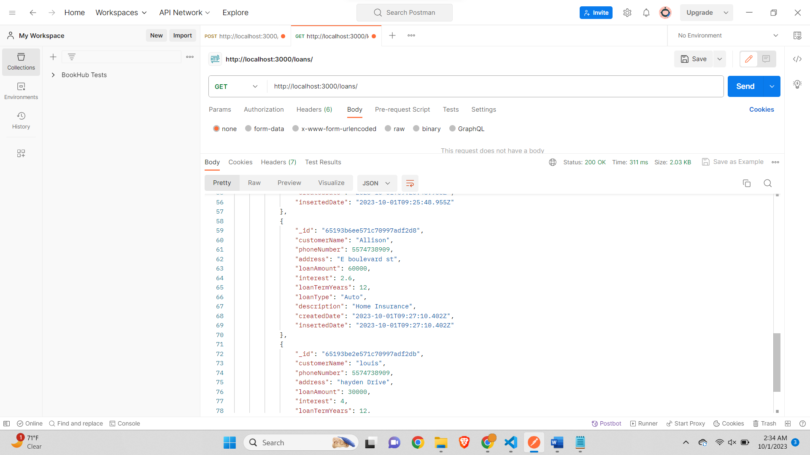

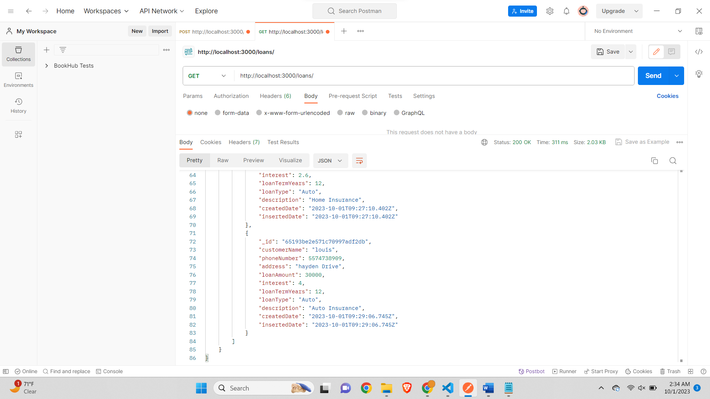

{

"status": "success",

"results": 6,

"data": {

"customerloan": [

{

"_id": "6518fdb5a66dcc5e06d6e0a0",

"customerName": "Margie Taylor",

"phoneNumber": 6758483838,

"address": "1010, E University Dr, tempe",

"loanAmount": 32000,

"interest": 2.5,

"loanTermYears": 15,

"loanType": "Home",

"description": "Home loan for Marie",

"createdDate": "2023-10-01T05:03:49.001Z",

"insertedDate": "2023-10-01T05:03:49.001Z"

},

{

"_id": "65193aa1e571c70997adf2d2",

"customerName": "Samantha",

"phoneNumber": 3636473892,

"address": "102 Apache st",

"loanAmount": 50000,

"interest": 3,

"loanTermYears": 3,

"loanType": "Auto",

"description": "Home Insurance",

"createdDate": "2023-10-01T09:23:45.601Z",

"insertedDate": "2023-10-01T09:23:45.601Z"

},

{

"_id": "65193ad9e571c70997adf2d4",

"customerName": "Jackson",

"phoneNumber": 8373829272,

"address": "E Broadway road",

"loanAmount": 20000,

"interest": 2,

"loanTermYears": 1,

"loanType": "Auto",

"description": "Home Insurance",

"createdDate": "2023-10-01T09:24:41.263Z",

"insertedDate": "2023-10-01T09:24:41.263Z"

},

{

"_id": "65193b1ce571c70997adf2d6",

"customerName": "Mike",

"phoneNumber": 654353425,

"address": "Mclintock Dr",

"loanAmount": 20000,

"interest": 3,

"loanTermYears": 5,

"loanType": "Auto",

"description": "Auto Insurance",

"createdDate": "2023-10-01T09:25:48.955Z",

"insertedDate": "2023-10-01T09:25:48.955Z"

},

{

"_id": "65193b6ee571c70997adf2d8",

"customerName": "Allison",

"phoneNumber": 5574738909,

"address": "E boulevard st",

"loanAmount": 60000,

"interest": 2.6,

"loanTermYears": 12,

"loanType": "Auto",

"description": "Home Insurance",

"createdDate": "2023-10-01T09:27:10.402Z",

"insertedDate": "2023-10-01T09:27:10.402Z"

},

{

"_id": "65193be2e571c70997adf2db",

"customerName": "louis",

"phoneNumber": 5574738909,

"address": "hayden Drive",

"loanAmount": 30000,

"interest": 4,

"loanTermYears": 12,

"loanType": "Auto",

"description": "Auto Insurance",

"createdDate": "2023-10-01T09:29:06.745Z",

"insertedDate": "2023-10-01T09:29:06.745Z"

}

]

}

}

**Step 11 – Get a Specific User (POSTMAN) Get the data of a specific user by entering this URL:** [**http://localhost:<PORT_NUMBER>/loans/:id**](http://localhost:%3cPORT_NUMBER%3e/loans/:id)

***Screenshot of the Postman request and response***

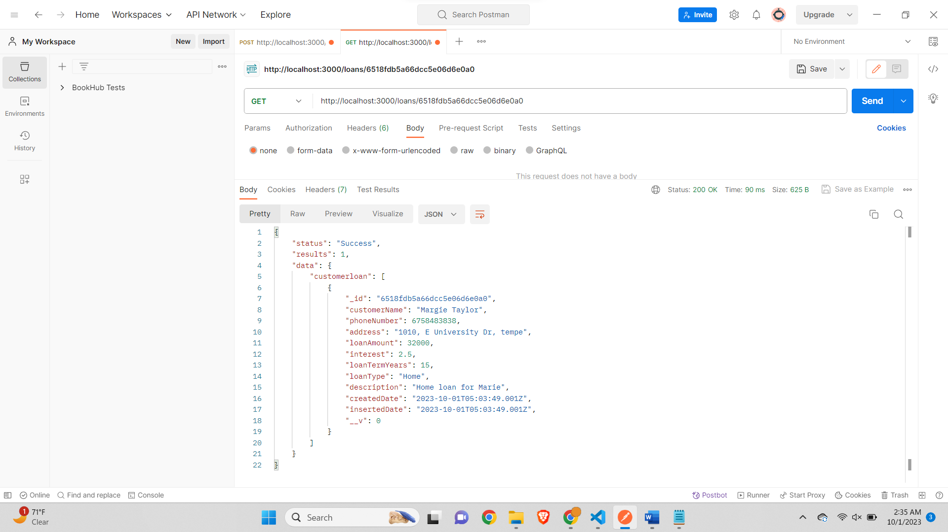

**Step 12 – Change an Existing Loan (POSTMAN) Change an existing Loan by using the PUT verb. Then change the value of the JSON object. The URL is the same as when we fetched the specific Loan.**

*Screenshots of the document before change (POSTMAN & Atlas MongoDB)*

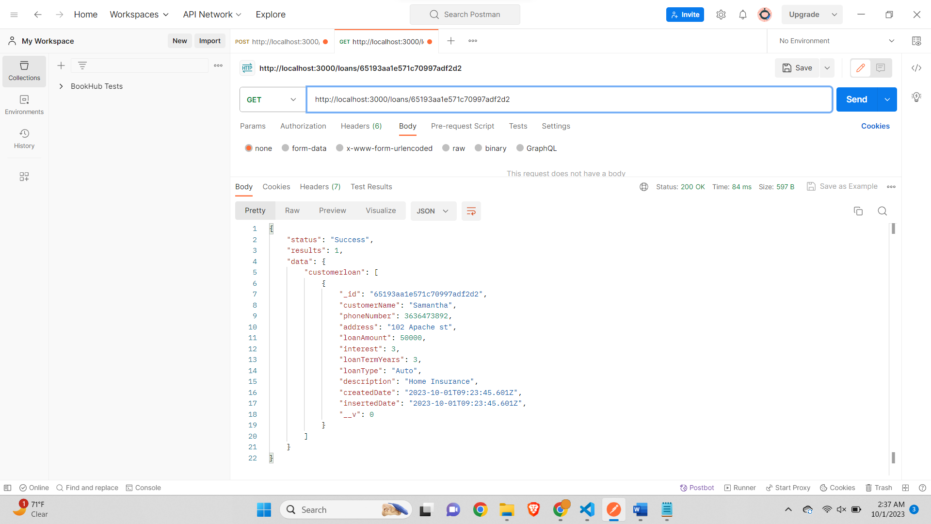

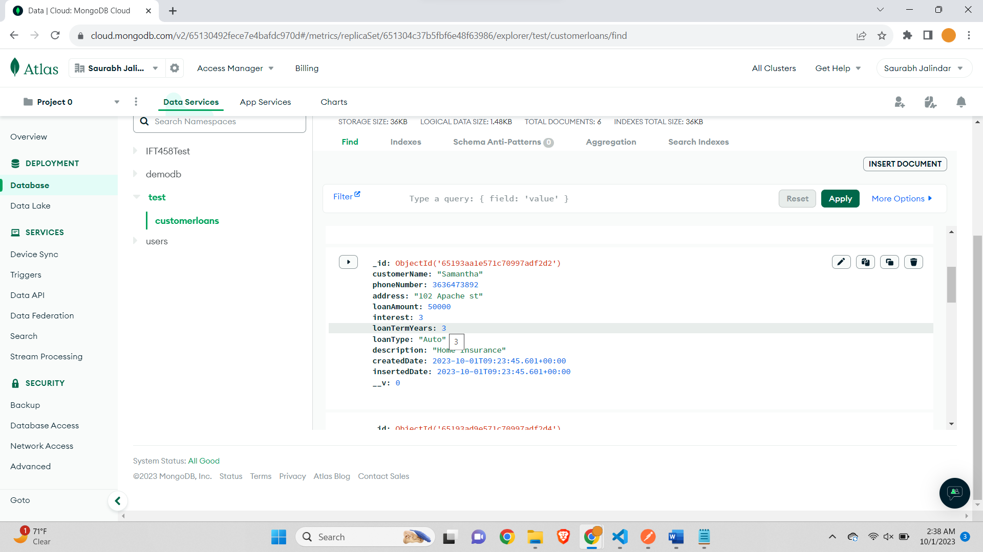

*Screenshot of the document after change (POSTMAN & Atlas MongoDB): Updated all Fields*

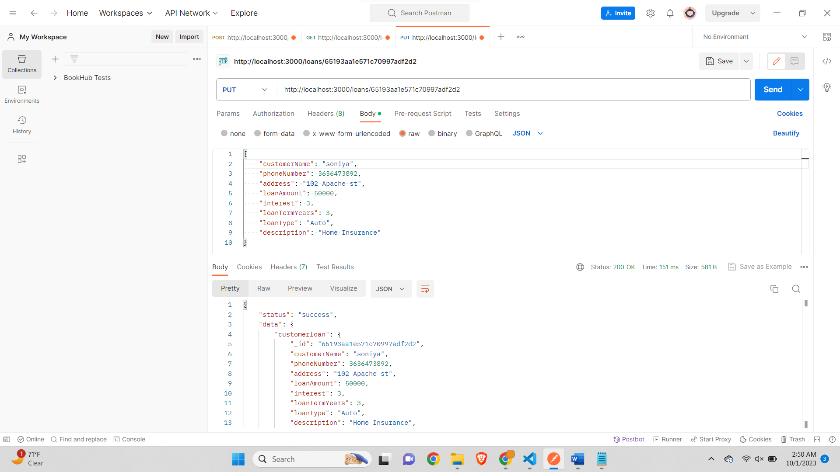

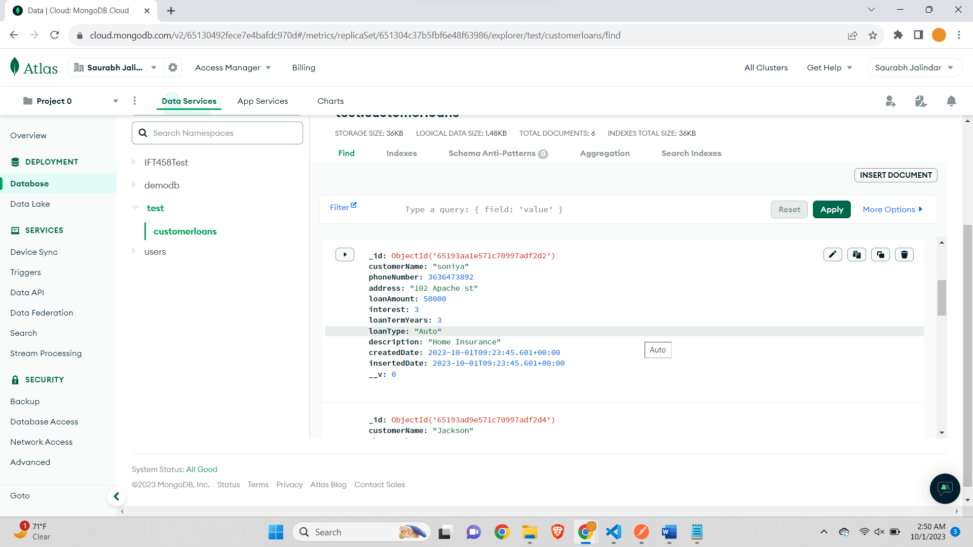

***Step 13 – To delete a loan, we only need to change the verb to DELETE. We can verify that the user is gone by fetching all the loans. Now Verify that you have a fully working express backend connected to a MongoDB database.***

*Screenshot of the Postman showing successful deletion of the document. Response 204.*

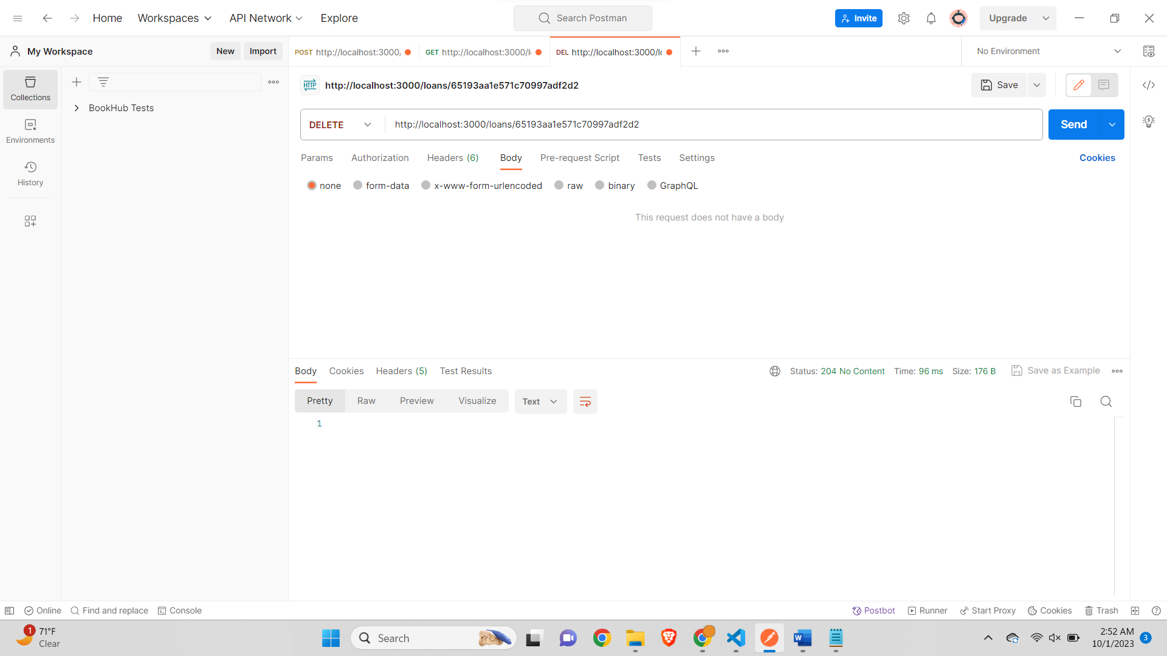

***Screenshot of the Postman verifying if a document with the id still exists or not. Output as expected. No document found.***

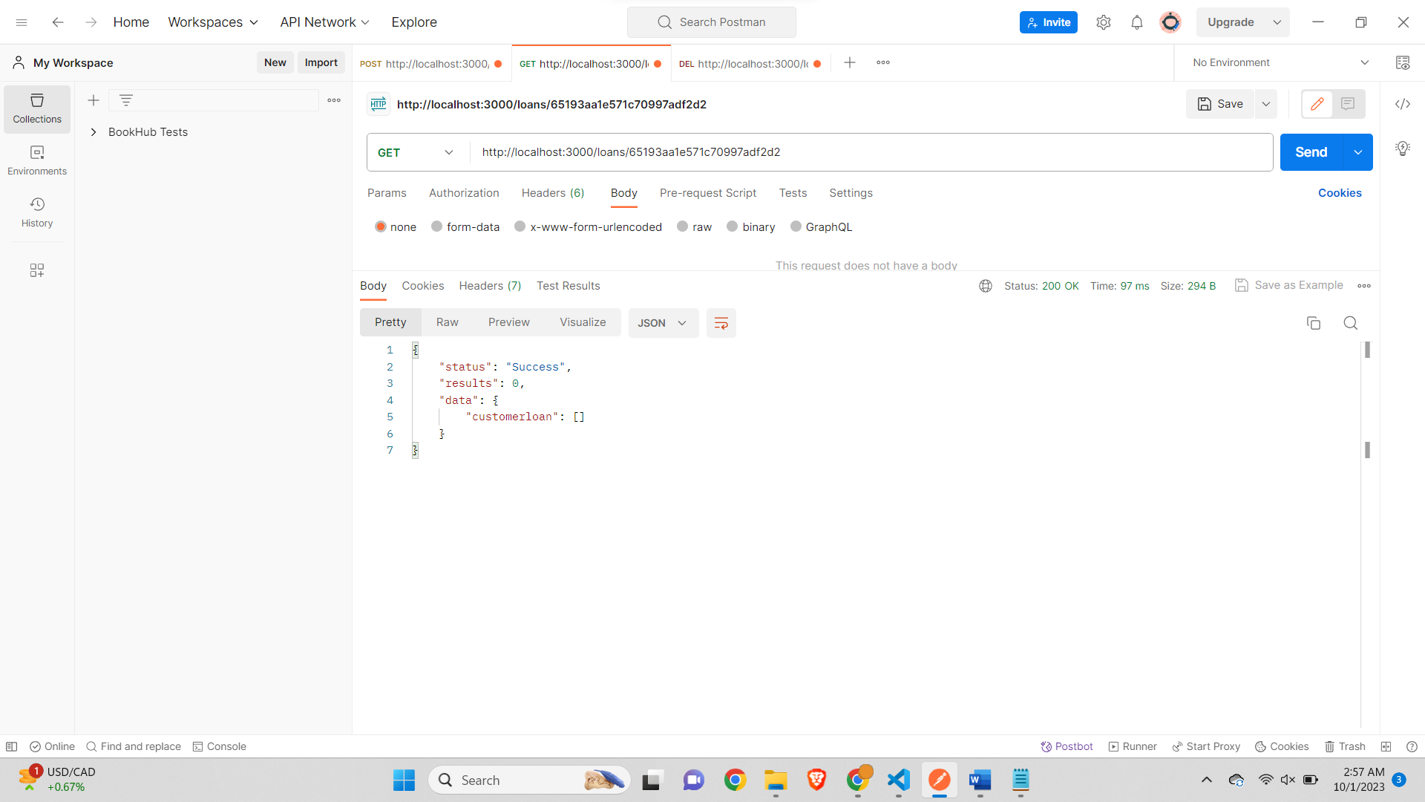

***Screenshot of the MongoDB Atlas – displaying 5 queries, previously it was 6.***

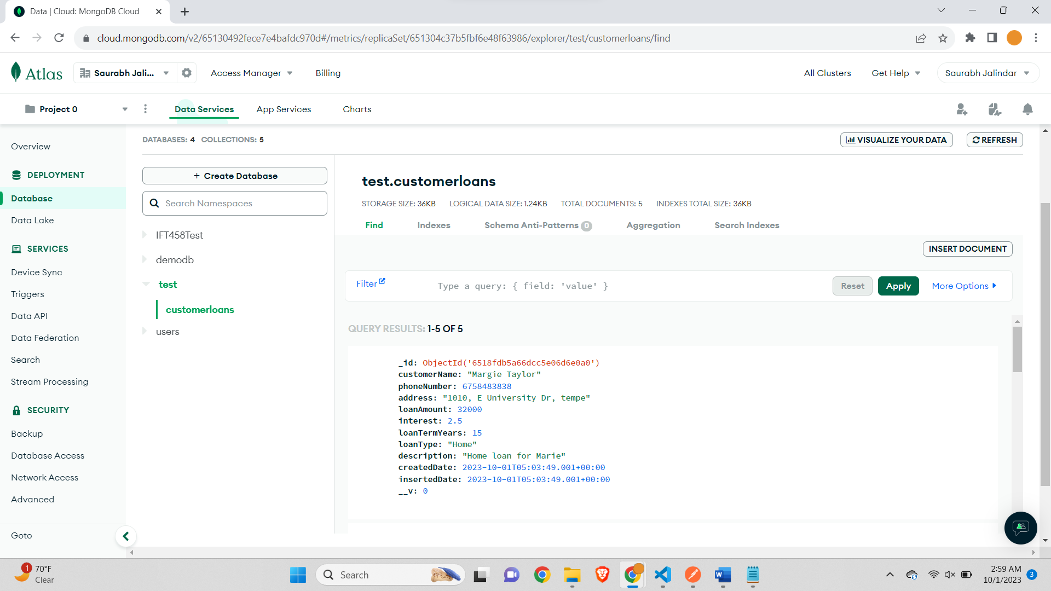

***Step 14 – Create a collection in POSTMAN and all your TEST there and then EXPORT POSTMAN TEST COLLECTION to a json file.***

*Screenshot of the collection in Postman containing all tests done so far in this assignment*

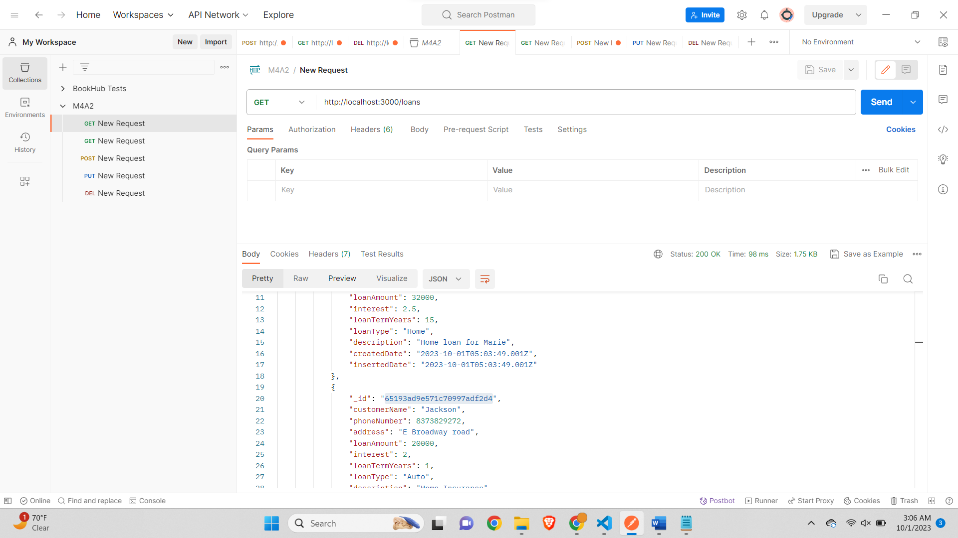

*Exporting the Postman collection as JSON file*

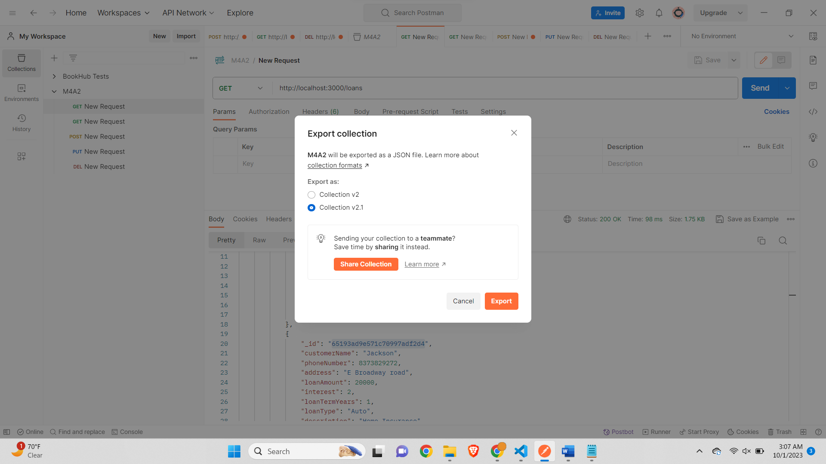

***Screenshot of exported json file-***

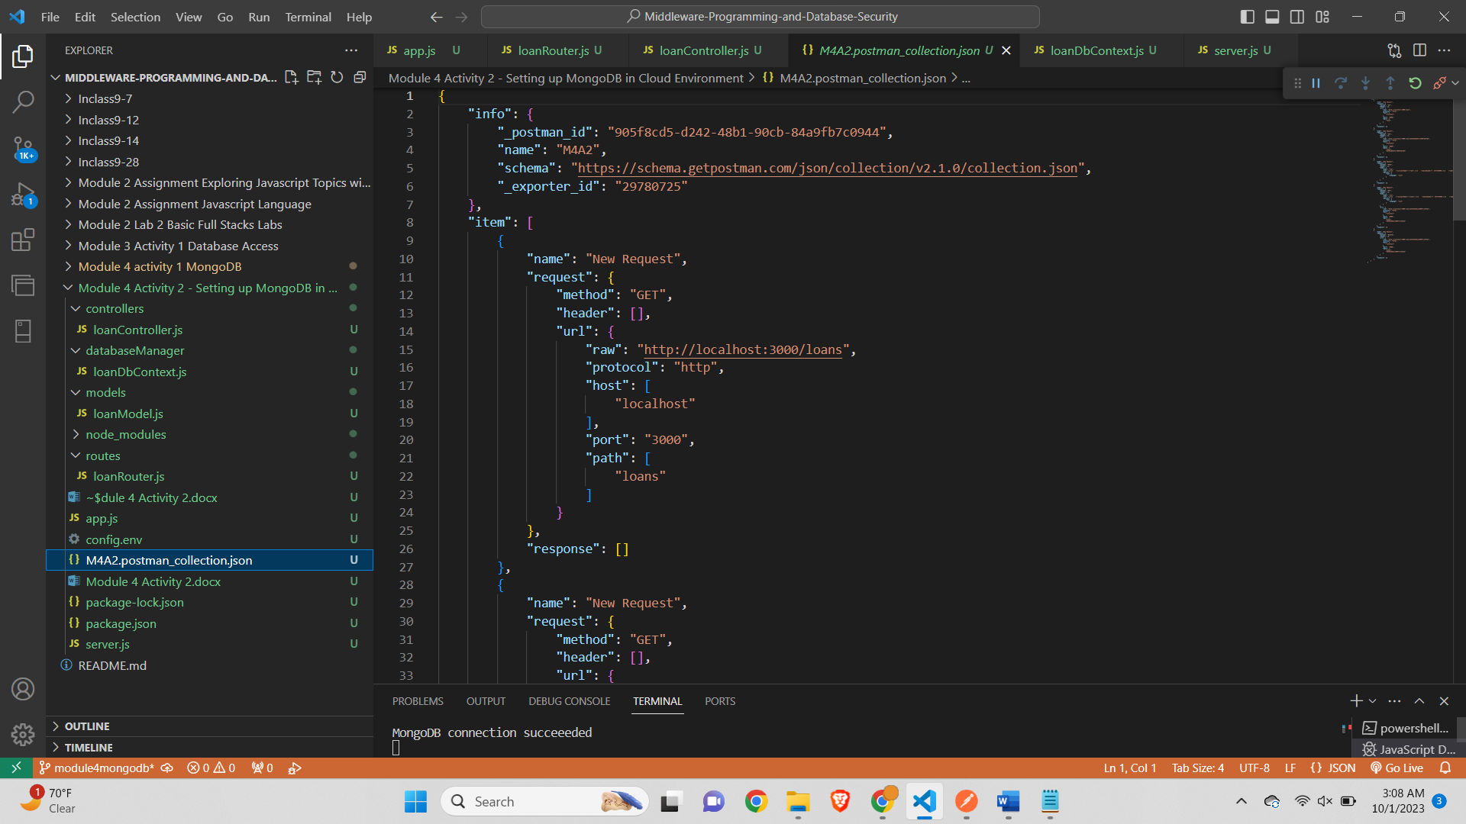 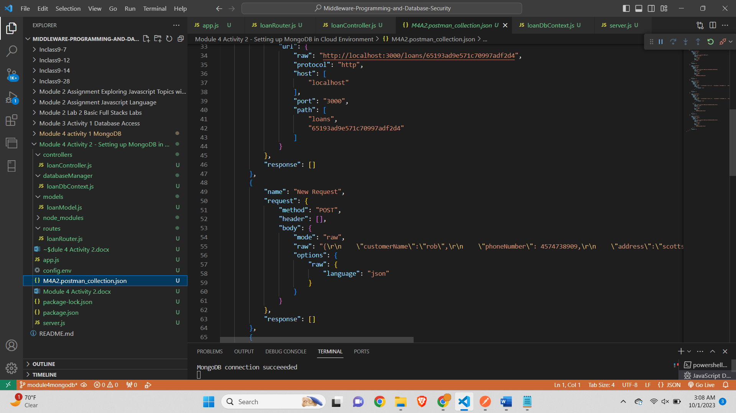

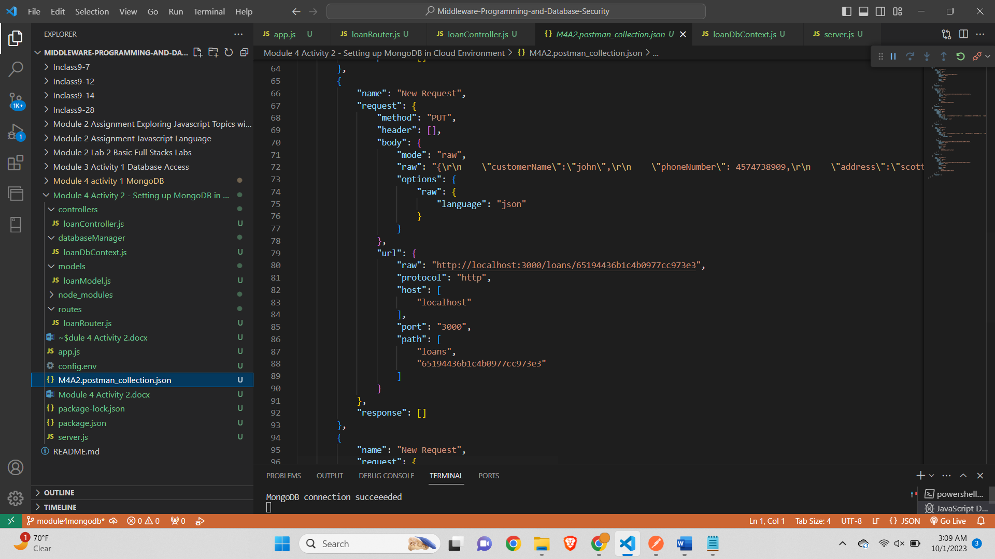

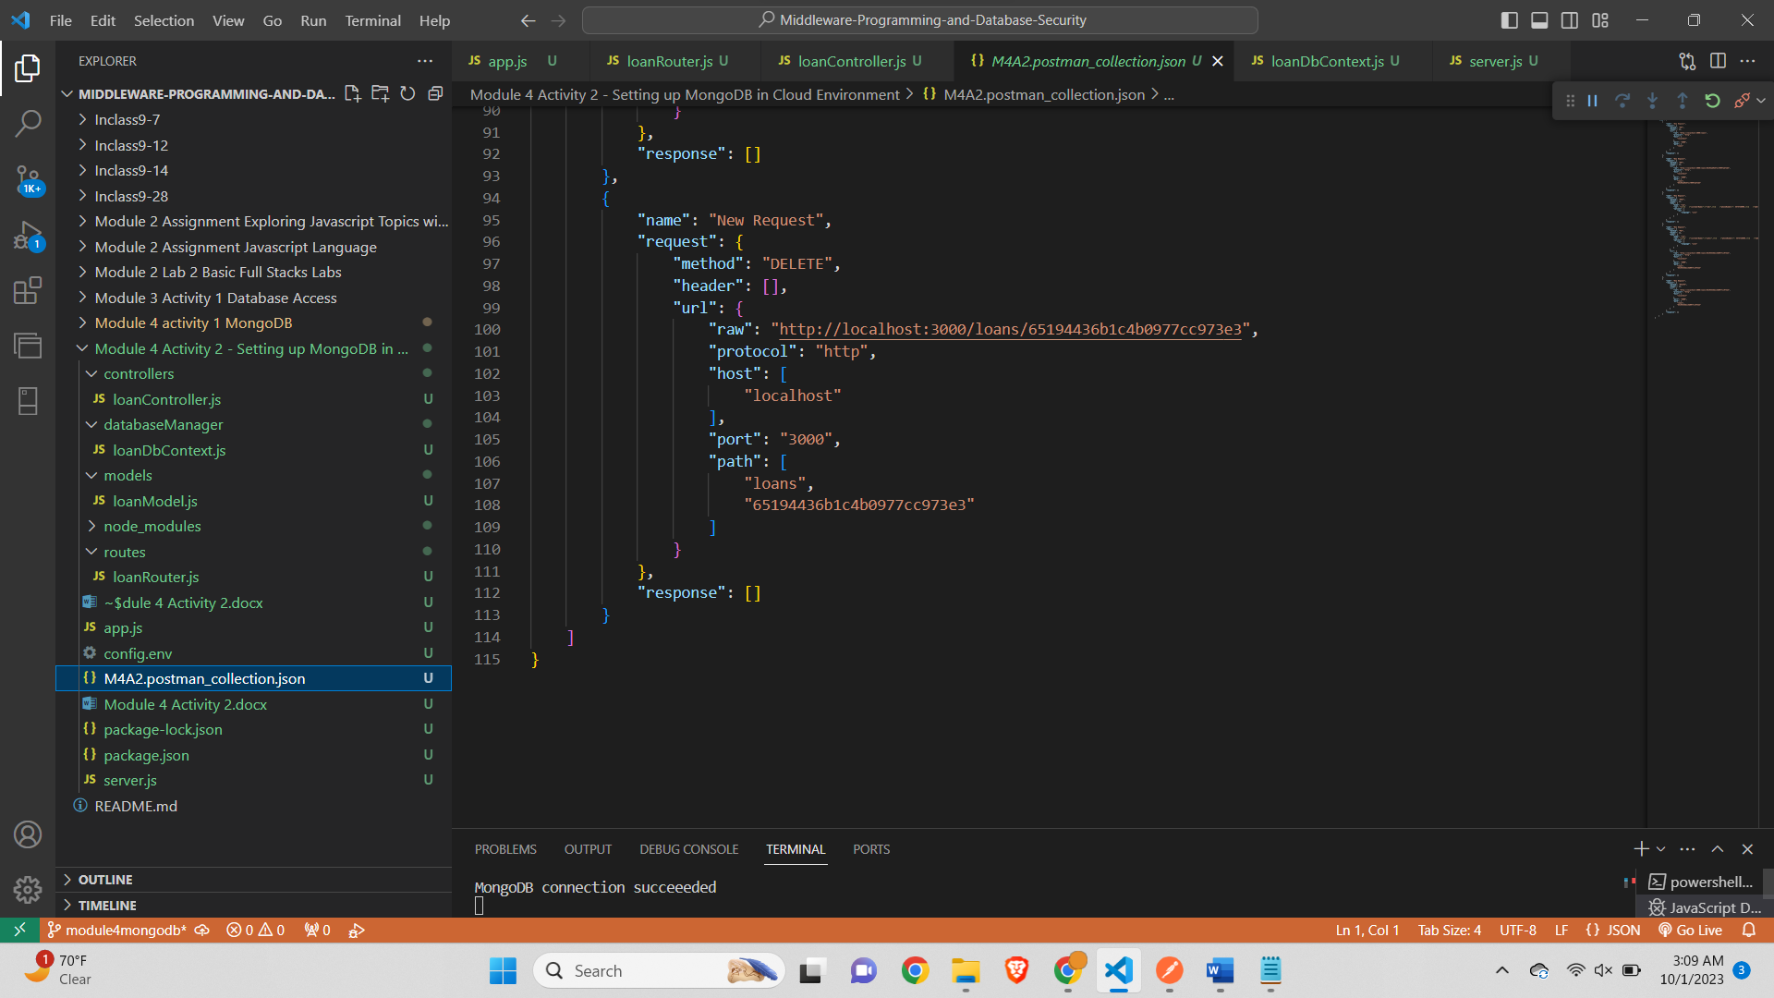

**Step 15 – Finally, add code to display the Connection String you used in the CONSOLE.**

*Screenshot of the server.js file showing the code (lines 12-13) added to display the DB connection string in output.*

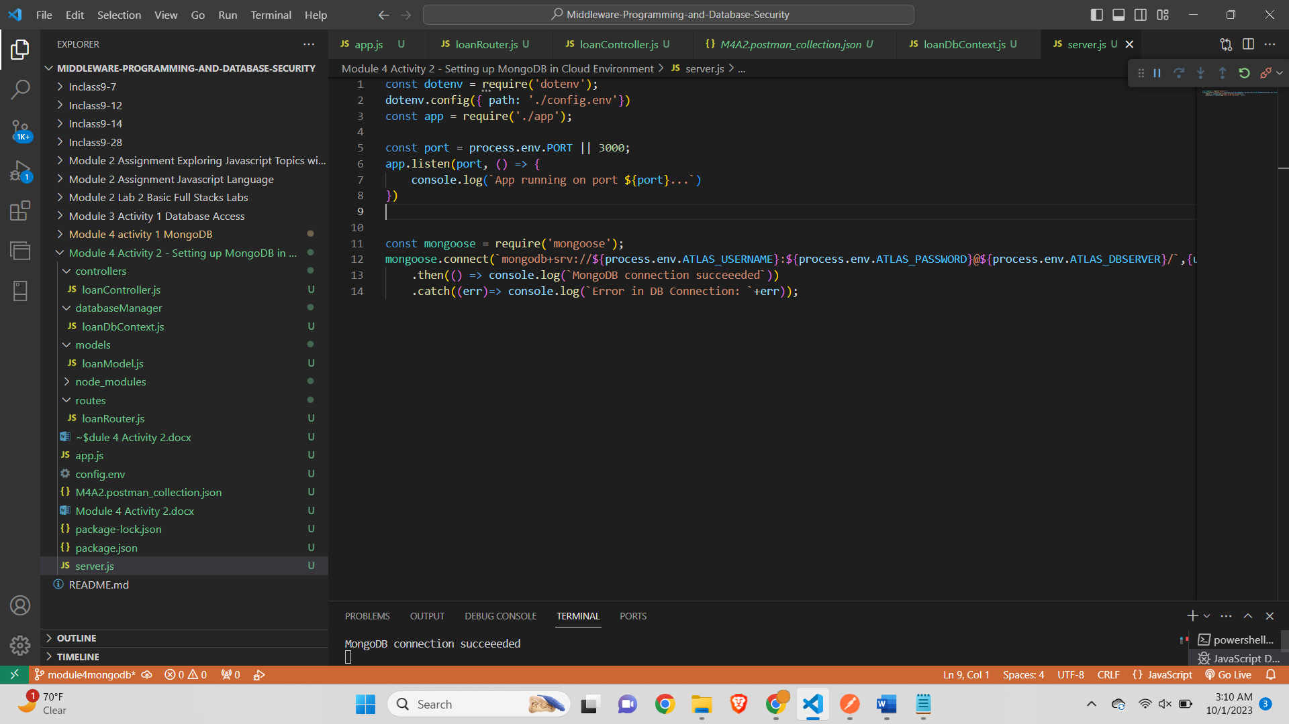

**TASK 2:** Extending code base to add new functionality. To add new functionality I have introduced name feature. Where we can find the loan details of the customer by the customer name.

To implement this feature I updated the code in following files-

loanController.js-

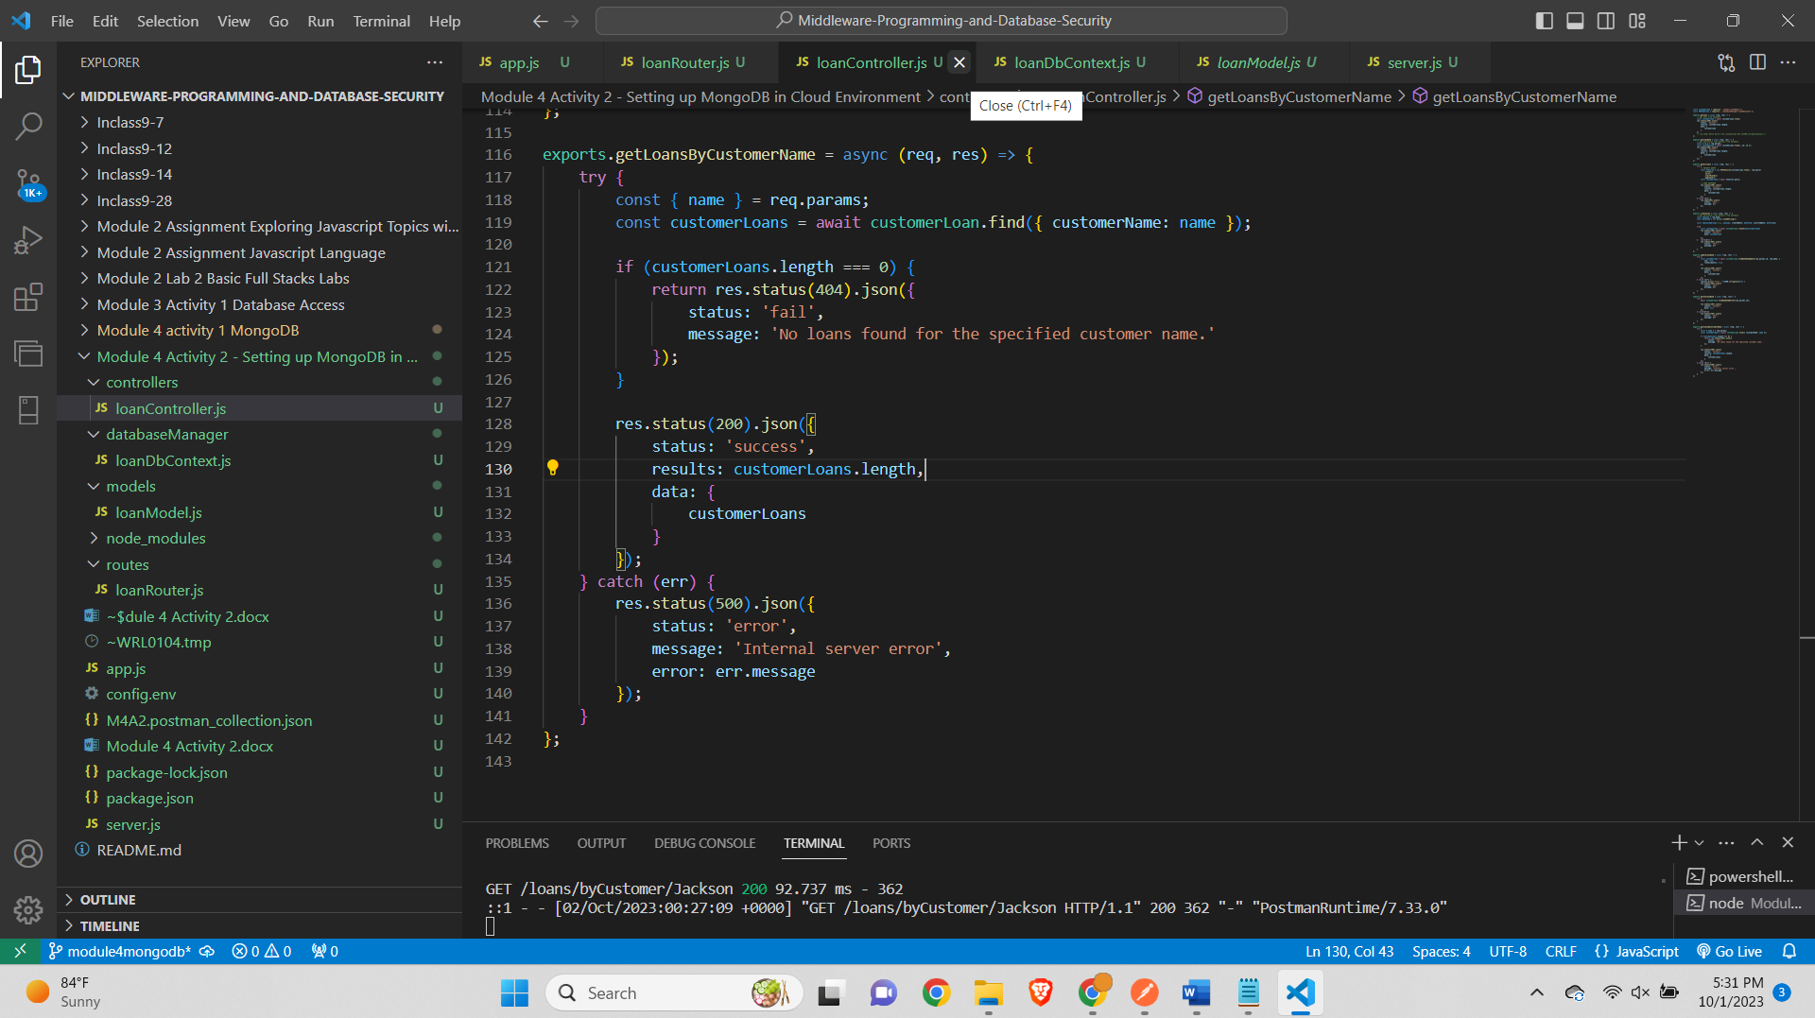

loanRouter.js-

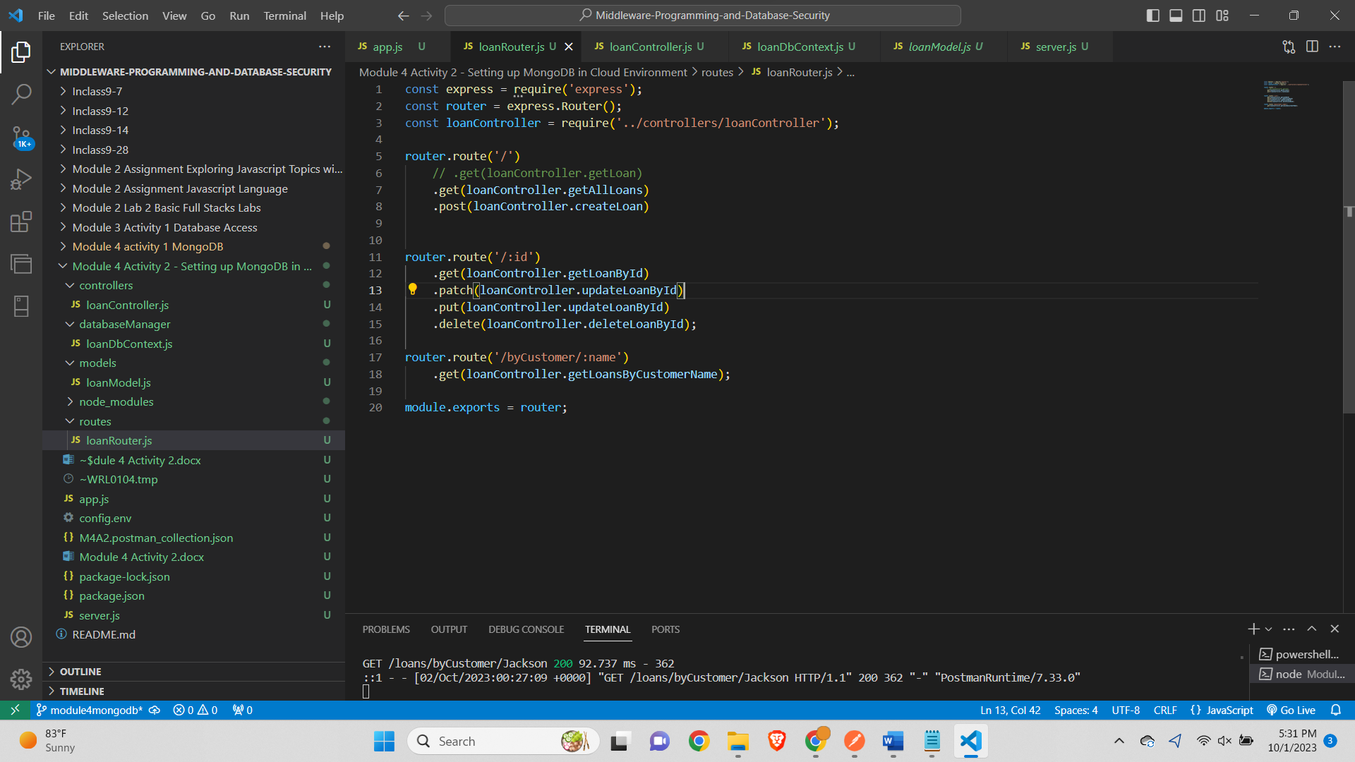

App.js-

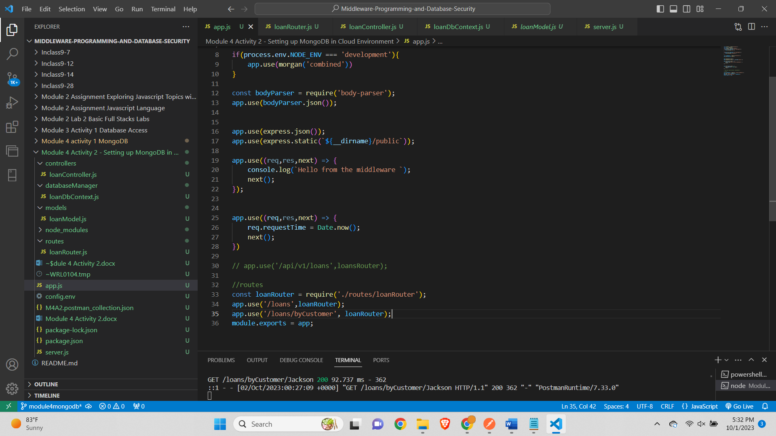

Feature implementation-

Get all customers-

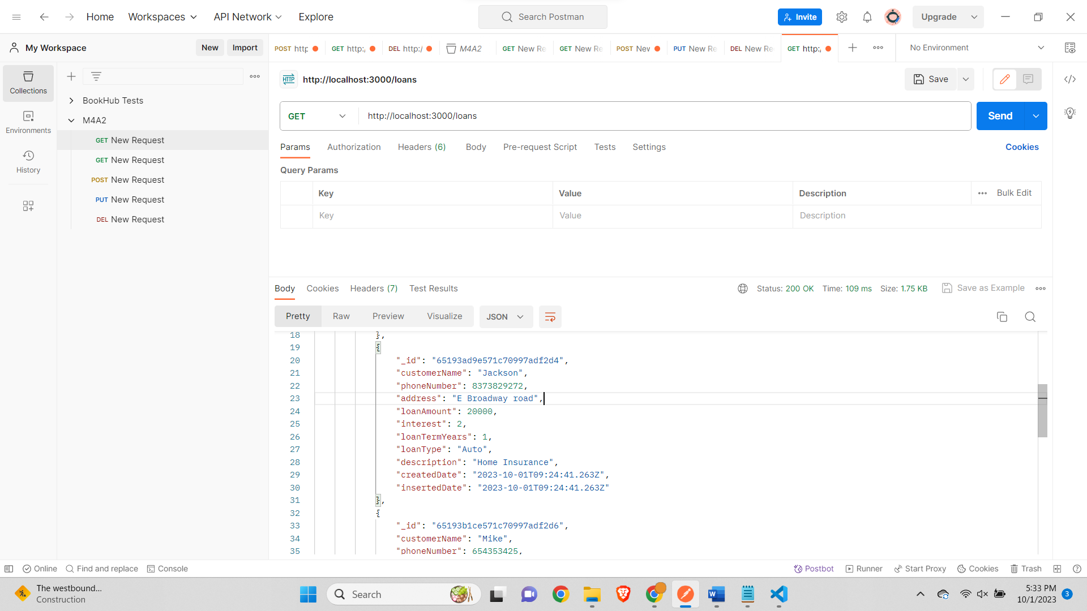

Get specific customer using customer name-

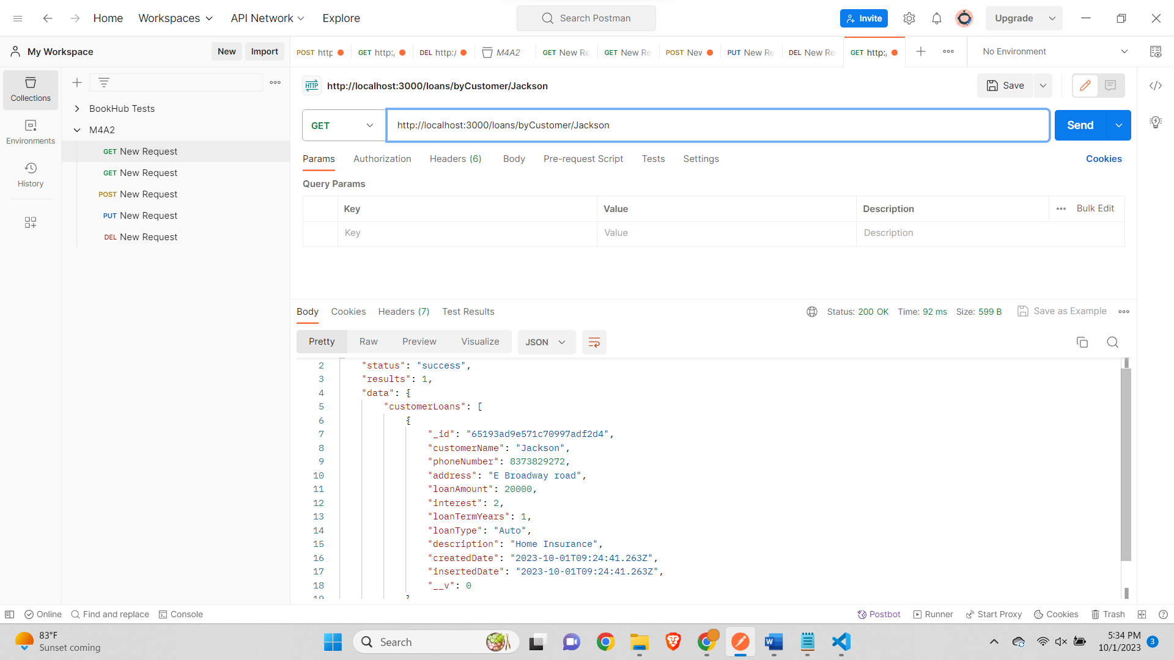

**Summary-**

The new feature added to the application allows users to retrieve loan records based on a specific customer's name. This enhancement introduces a more granular search functionality, making it easier to access loan information for a particular customer.

The feature consists of a new API endpoint, **/loans/by-customer/:name**, where **:name** is a dynamic parameter representing the customer's name. When a GET request is made to this endpoint with a customer's name, the application queries the MongoDB database and returns a list of loan records associated with that customer.

The implementation adheres to best practices, with robust error handling to handle scenarios where no loans are found for the specified customer name. It provides a clear and informative response to the client, ensuring a user-friendly experience.

This addition enhances the application's versatility and usability, particularly in scenarios where users need to access loan data for specific customers quickly. It seamlessly integrates with the existing codebase and maintains the application's overall structure and consistency.

**TASK 3:**

**Understanding of the Codebase:** The provided codebase is well-structured and easy to understand. It follows the Model-View-Controller (MVC) architectural pattern, with clear separation of concerns. The codebase is organized into different modules: server.js, app.js, loanRouter.js, loanController.js, loanDbContext.js, and loanModel.js. Each module has a specific responsibility, making it easy to locate and modify code related to a particular aspect of the application.

The interaction between different parts of the code is seamless. server.js sets up the server and establishes the MongoDB connection using Mongoose. app.js defines the Express application and middleware, handling routing and request parsing. loanRouter.js defines the API routes, loanController.js contains the route logic, and loanModel.js defines the Mongoose schema for loan data.

Mongoose is used effectively to define the loan schema, which maps to the MongoDB collection. This schema includes validation rules for each field, ensuring data integrity. The use of Mongoose also simplifies database interactions by providing a higher-level abstraction.

**Comparing Past Experience and New Learning:** This project provided valuable learning experiences, particularly in the context of MongoDB and Mongoose. In previous projects, I had primarily worked with relational databases, so learning how to set up and connect to a NoSQL database like MongoDB was a new and insightful experience. I learned how to establish a MongoDB connection using environment variables and handle connection errors.

Diving into Mongoose was also a significant learning point. It allowed me to define data models in a more structured and flexible manner, as opposed to traditional SQL databases. The use of Mongoose schemas and models simplified data validation and querying.

**Differences and Similarities:** Compared to my past projects, this assignment was different due to the use of MongoDB and Mongoose. The main challenge I faced was setting up the MongoDB connection and handling connection errors, which was not a concern with traditional relational databases. However, the structure of the codebase and the MVC architecture remained familiar, making it easier to adapt to the new database technology.

**Extension of the Codebase:** I extended the codebase by adding a new feature that allows users to retrieve loan records by a specific customer's name. This feature seamlessly integrates with the existing codebase, following the established MVC pattern. Challenges included handling scenarios where no loans were found for the specified customer name, which required robust error handling.

**Testing:** I conducted thorough testing of the application using Postman. I tested all API routes, including GET, POST, PUT, and DELETE, using both JSON bodies and query parameters. This testing process ensured that the routes functioned correctly and contributed to the reliability of the application.

**Learning Reflection:** This assignment significantly expanded my knowledge of databases and introduced me to NoSQL databases like MongoDB and the Mongoose ORM. I gained a deeper understanding of how to structure and organize a Node.js application following best practices. Additionally, I improved my error handling skills and learned how to implement complex database queries with Mongoose. Overall, this project has contributed to my growth as a developer, enhancing my ability to work with diverse technologies and design robust, maintainable applications.

Git Repository-